FINAL REPORT Nr.2/2009

OF THE AIRCRAFT SERIOUS INCIDENT

INFRINGEMENT OF SEPARATION STANDARDS BETWEEN THE AIRBALTIC AIRCRAFT BOEING 735, YL-BBA, FLIGHT BTI6C4 AND LATCHARTER AIRCRAFT AIRBUS A-320, YL-BCB, FLIGHT LTC306 DURING APPROACH IN THE TERMINAL CONTROL AREA OF RIGA INTERNATIONAL AIRPORT ON JULY 25, 2008

The Transport Accident and Incident Investigation Bureau of the Republic of Latvia is a governmental, independent of all aviation authorities’ organization, established by law to investigate and determine the cause or probable cause of accidents and serious incidents that occurred in the civil aviation, as well, if necessary for enhancing flight safety, incidents.
The sole purpose of such investigation is in accordance with Annex 13 of the Convention of Chicago, as well as the Directive 94/56/EC of 21 November 1994, establishing the fundamental principles governing the investigation of civil aviation accidents and incidents of the Council of the European Union, to prevent accidents and incidents and, if the Bureau finds it appropriate, to issue safety recommendations. The purpose of an investigation conducted under the responsibility of the Transport Accident and Incident Investigation Bureau Republic of Latvia is not to apportion blame or liability.

Address:
58 Brivibas Str., Riga
LV-1011, Latvia
Phone: +371 67288140
Fax: +371 67283339
E-mail: taiib@taiib.gov.lv

Director of Transport Accident
and Incident Investigation Bureau Ivars Alfreds Gaveika

FINAL REPORT Nr.2/2009

OF THE AIRCRAFT SERIOUS INCIDENT

INFRINGEMENT OF SEPARATION STANDARDS BETWEEN THE AIRBALTIC AIRCRAFT BOEING 735, YL-BBA, FLIGHT BTI6C4 AND LATCHARTER AIRCRAFT AIRBUS A-320, YL-BCB, FLIGHT LTC306 DURING APPROACH IN THE TERMINAL CONTROL AREA OF RIGA INTERNATIONAL AIRPORT ON JULY 25, 2008

TABLE OF CONTENTS

Synopsis………………………………………………………………………………..………4

Notification…………………………………………………………………………………….6

1. FACTUAL INFORMATION……………………………………………………...…6

1.1. History of the flight…………………………………………………………………….6
1.2. Injuries to persons…………………………………………………………………..…12
1.3. Damage to aircraft…………………………………………………………………….12
1.4. Other damage……………………………………………………………………….....12
1.5. Personnel Information……………………………………………………………...…12
1.6. Aircraft information………………………………………………………………...…13
1.7. Meteorological information………………………………………………………...…13
1.8. Aids to Navigation……………………………………………………………….……13
1.9. Communications………………………………………………………………………15
1.10. Aerodrome information………………………………………………………….……15
1.11. Flight recorders………………………………………………………………………..15
1.12. Wreckage and impact information……………………………………………….……15
1.13. Medical and pathological information…………………………………………...……15
1.14. Fire……………………………………………………………………………….……16
1.15. Survival aspects……………………………………………………………………….16
1.16. Tests and research…………………………………………………………………..…16
1.17. Organizational and management information…………………………………..….…16
1.17.1. Quality management system……………………………………………………..……21
1.17.2. Safety Management System…………………………………………………..………23
1.18. Additional information………………………………………………………..………24
1.19. Useful or effective investigation techniques……………………………………..……26

2. ANALYSIS………………………………………………………………………...…24

3. CONCLUSIONS…………………………………………………………………..…30

4. FLIGHT SAFETY RECOMMENDATIONS…………………………………...…32

Abbreviations
ATCC - Air Traffic Control Centre
ACC - Area Control Center
ATRACC - ATC System for Riga Area Control Centre
A-SMGCS - Advanced-Surface Movement Guidance and Control System
ACFT - Aircraft
SSR - Secondary Surveillance Radar
PSR - Primary Surveillance Radar
ARCC - Aeronautical Rescue Co- ordination Centre
ATC - Air Traffic Control
UTC - Universal Time Coordinated
UTA - Upper (Traffic) Control Area
CTA - Control Area
TMA - Terminal Control Area (ICAO)
TIA - Traffic Information Area
TIZ - Traffic Information Zone
AoR - Areas of Responsibility
CWP - Controller Working Position
Report RVSM - Reduced Vertical Separation Minimum
ODS - Operator input and Display System
APP - Approach
VOR - VHF Omni Directional Range
ILS - Instrument Landing System
DME - Distance Measuring Equipment
NM - Nautical mile
FT - Feet
MSL - Mean Sea Level
Z - Zulu = Universal Coordinated Time (UTC)
STAR - Standard Instrument Arrival
ESARR5 - EUROCONTROL Safety and Regulatory Requirement on ATM personnel
FIR - Flight Information Region
UIR - Upper (flight) Information Region
FIS - Flight Information Services
ATS - Air Traffic Services
FPL - Filed Flight Plan (ICAO format)
RPL - Repetitive Flight Plan
HMI - Human Machine Interface
EHSI - Electronic Horizontal Situational Indicator
OSUP - Operational Supervisor
FAP - Final Approach Point
METAR - Meteorological Aviation Routine Weather
CAVOK - Ceiling and Visibility OK
VMC - Visual meteorological condition
SAR - Search and Rescue
CISM - Critical Incident Stress Management
SSR - Secondary Surveillance Radar
ESARR - Eurocontrol Safety and Regulatory Requirement
PANS-ATM - Procedures for Air Navigation Services-Air Traffic Management
STCA - Short-Term Conflict Alert
CTR - Control Zone
FL - Flight Level
RBPS - Radar Bypass System
ACFT - Aircraft

Synopsis

Unless stated otherwise the time in this Report is UTC
On Friday, July 25, 2008 the two passenger aircraft entered RIGA ACC controlled airspace. Aircraft were being controlled by Riga ACC controller responsible for the ACC Approach sector. An airBaltic Boeing 735, registered YL-BBA, flight BTI6C4 was inbound to Riga International airport (EVRA), Latvia on a scheduled passenger service from National/Zaventem airport (EBBR), Brussels (Bruxelles), Belgium.

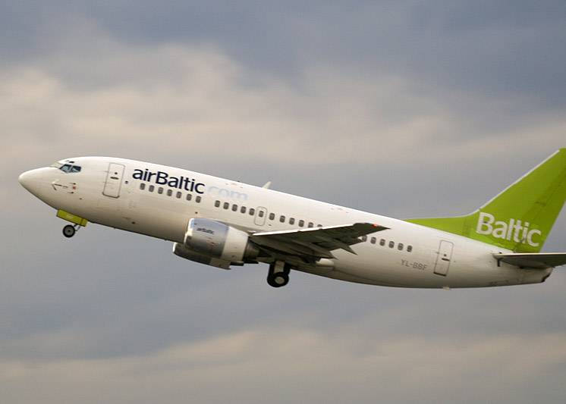Picture 1

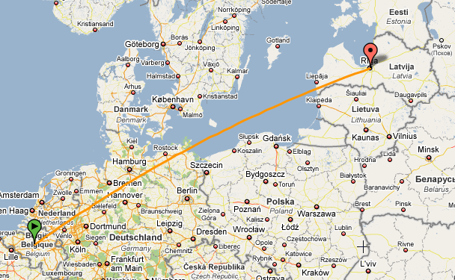
Picture 2
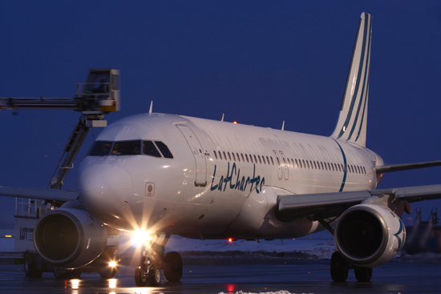

Picture 3

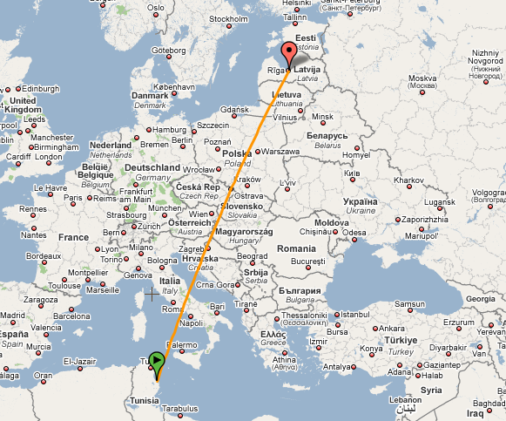

Picture 4
Latcharter Airbus A320, registered YL-BCB, flight LTC306 was inbound to Riga International airport (EVRA), Latvia on a charter passenger service flight from Habib Bourguiba/Skanes airport (DTMB), Monastir, Tunisia.
At 20:37 UTC a serious aircraft incident took place in the Riga FIR - loss of separation between airBaltic Boeing 735, flight BTI6C4 and LatCharter Airbus A320, flight LTC306 while on approach to Riga International Airport (56:55:25N 023:58:16E). Both aircraft had approximately equal flight level, when LTC306 was crossing FL70 there was BTI6C4. Two aircraft passed each other and the separation standard between the two aircraft was infringement Minimal distance between aircraft was 4,1NM.

Notification

The Transport Accident and Incident Investigation Bureau of the Republic of Latvia was notified about the incident on Saturday, July 26, 2008 at 8:47 local time by the duty officer of ARCC Riga, a structural part of LGS responsible for co-ordination of SAR operations within Riga FIR, Riga International Airport.
TAIIB Authorities had evaluated the received information relevant to that case and initiated formal investigation into this serious incident, under the provisions of Annex 13 to the Convention on International Civil Aviation (Chicago 1944) and the Republic of Latvia Cabinet Regulation No 660, Adopted 25 November 2003 as well as forwarded request to airBaltic and LatCharter of providing any relevant available information regarding to the aircraft and personal data of flight crew involved in the serious incident.

1. FACTUAL INFORMATION

1.1. History of the flight

1. Flights involved in the incident
The two aircraft involved in this incident were flying, almost simultaneously, on converging routes to their destination airport Riga International, respectively BTI6C4 from the west on heading 077º and LTC306 on route GUNTA (562217N 0234520E) from the south, into the Riga TMA, APP controlled airspace.
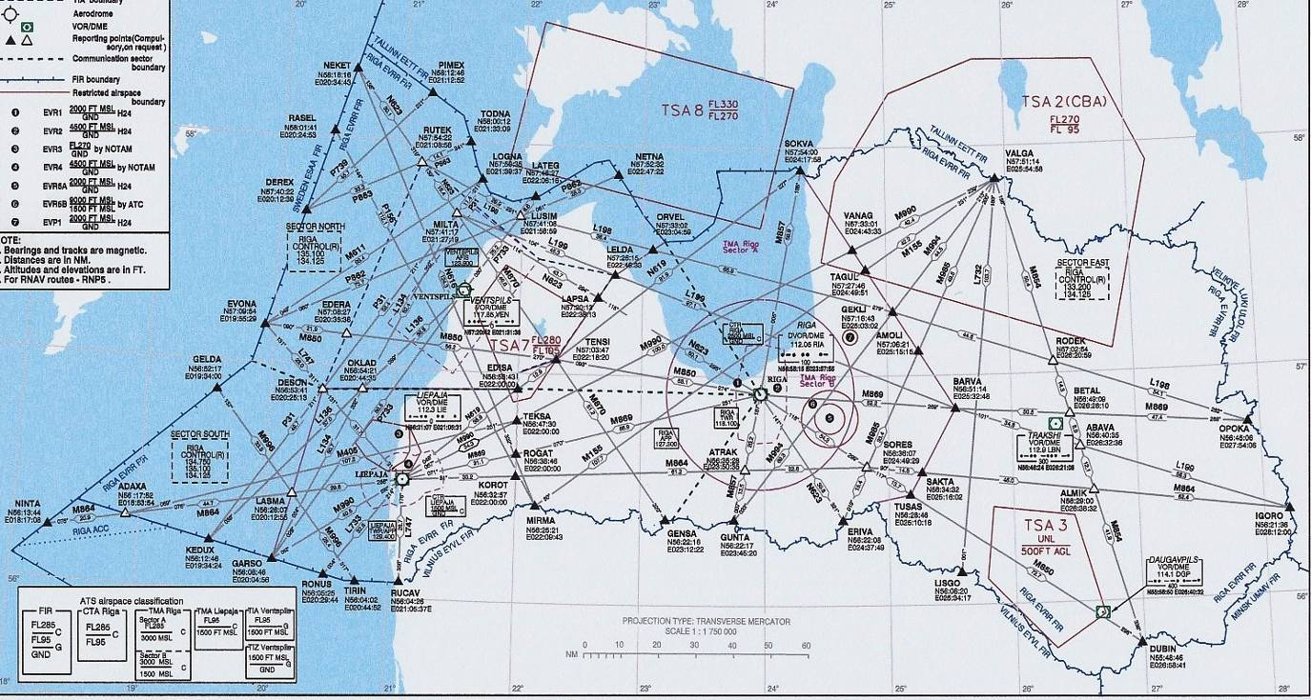

Picture 5, ENROUTE CHART GUNTA

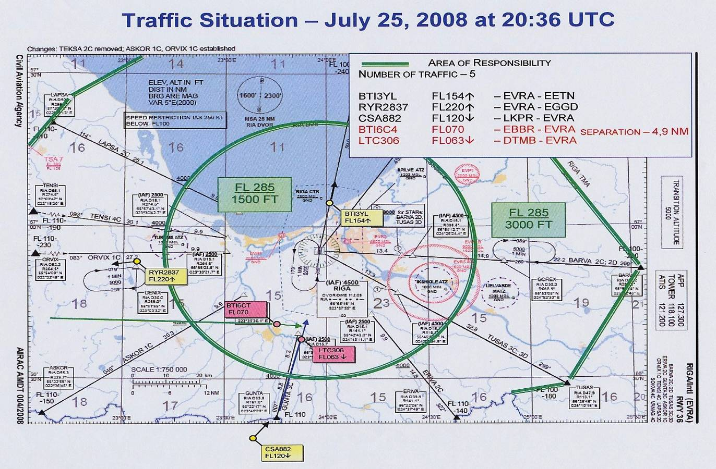

Picture 6

On its first contact with Riga APP controller, BTI6C4, Boeing 735, indicated descending to flight at FL130, had cleared to FL 60 on present heading (077º) and given vectors for ILS approach RWY36. BTI6C4 approved clearance and declared that they are ready for short final, it means that the crew requested ACC Riga APP controller to track direct short final to runway 36 at Riga International Airport. Riga APP controller had informed BTI6C4 that according to approach sequence it will be No3 to land and must expect ILS approach RWY 36, because LTC306, which approached from Vilnius FIR had planned as No1. According to rules IFR flights entering and landing within a Terminal Control Area will be cleared to proceed via STAR, route and/or radar vector.
The air traffic APP controller responsible for the APP sector observed this development of situation on his radar monitor.
At 20:27:02 controller requested BTI6C4 to notify it air speed and instructed the crew to reduce air speed to 250 kt.
At 20:30:46 LTC306 contacted Riga APP controller and declared descending FL110 to compulsory reporting point GUNTA (562217N 0234520E). Controller instructed LTC306 to continue descend to FL 100, to keep air speed 300 kt and to report when ready to reduce speed to 250 kt. Controller originally assumed that the increasing of aircraft air speed would be able to be maintained acceptable separation minima.
At 20:31:45 controller instructed crew of BTI6C4 to reduce airspeed to 220 kt. According to his admission, these measures would be enough for averting conflict situation between aircraft and little later, at 20:32:21 instructed LTC306 to continue descend to altitude 2500 ft, QNH 1020.
A few seconds later, at 20:33:12 seeing that there could develop conflict situation, because air speed control did not give a desirable result, controller turned BTI6C4 right giving instruction – “Air Baltic 6C4 right, heading 085”.
At 20:33:46 controller gave instruction for LTC306 – “Latcharter 306 cleared ILS approach RWY36, report established on localizer”, the crew copied clearance and little later at 20:34:57 reported about decreasing air speed to 250 kt as was instructed by controller early.

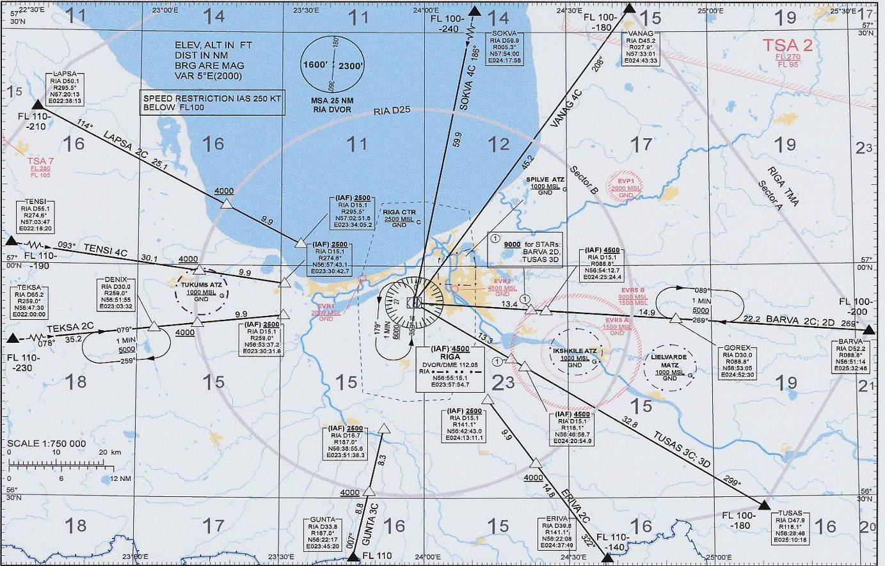

Picture 7, STANDARD ARRIVAL CHART-INSTRUMENT RIGA/Intl RWY 36
Date: 25.07.2008 Time: 20.26-20.39 (UTC)

ACC: Riga Approach (frequency 127,3 MHz)

TIME (UTC) |  | THE RADIOTELEPHONY
20.26.25 | P (pilot) | Riga Approach good evening, Air Baltic 6C4 descending FL 130 on heading 077, ja, information “O”
 | C (contr) | Air Baltic 6C4, Riga Approach, good evening, radar contact, vectors for ILS approach RWY36. On present heading descend FL 60
 | P | Descending FL 60 on present heading, expect radar vectors for ILS RWY36, Air Baltic 6C4
20.27.02 | P | Air Baltic 6C4 ready for short final
 | C | Air Baltic 6C4 will be N3 to land, expect ILS approach RWY36, you have to reduce speed. What is your indicated speed now?
 | P | 280 now
 | C | Air Baltic 6C4 start reducing your speed to 250 knots
 | P | Reducing to 250, Air Baltic 6C4
20.30.46 | P | Riga Approach, hallo, Latcharter 306, good evening descending FL 110 to Gunta
 | C | Latcharter 306 Riga Approach good evening, radar contact, after Gunta”Gunta 3C” arrival, continue descend FL 100. What is your indicated air speed?
20.31.06 | P | Indicated speed 300, after Gunta “Gunta 3C”, Latcharter 306
 | C | Latcharter 306 copied that, keep speed 300 knots and report when ready reducing to 250
 | P | Will report when reducing 250 and maintaining 300, Latcharter 306
20.31.45 | C | Air Baltic 6C4 speed 220 knots
 | P | Speed 220 knots, Air Baltic 6C4
20.32.21 | C | Latcharter 306 continue descend to altitude 2500 ft,  QNH 1020
 | P | 1020, descend 2500 ft, Latcharter 306
20.33.12 | C | Air Baltie 6C4 right, heading 085
 | P | Right, heading 085 Air Baltic 6C4
20.33.46 | C | Latcharter 306 cleared ILS approach RWY36, report established on localizer
 | P | Cleared ILS approach RWY36, will report established on localizer RWY36, Latcharter 306
20.34.57 | P | Riga Approach, Latcharter 306 decreasing airspeed to  250
 | C | Latcharter 306 copied
20.35.25 | C | Air Baltic 6C4 recleared to descend FL 70 initially
 | P | Recleared to descend FL 70 initially, Air Baltic 6C4
 | C | Latcharter 306 turn right 10 degrees, report new heading
 | P | Turn right 10 degrees and heading will be 210... 020,  Latcharter 306
 | C | Latcharter 306 copied, on heading 020 still cleared ILS approach RWY36
20.35.57 | P | Cleared for ILS approach RWY36 on present heading, Latcharter 306
 | C | Latcharter 306 on your heading
 | P | On heading Latcharter...(unreadable)... congratulations... (?)
20.36.15 | C | Latcharter 306 expedite vacating FL 70
 | P | Expediting Latcharter 306
20.36.29 | C | Air Baltic 6C4, N1 traffic is now your at 2 o'clock from left to right, separation 6 miles, now crossing FL 65, descending
 | P | Copied...6C4, he is from the right side
 | C | 6C4 that's correct, on the right
 | P | It's not good
20.37.47 | C | Air Baltic 6C4 continue descend FL 60
 | P | Blocked…
 | C | Air Baltic 6C4 descend FL 60
 | P | Descend FL 60, Air Baltic 6C4
20.38.32 | P | Riga Approach Latcharter 306 established on localizer for RWY36
 | C | Latcharter 306 contact TWR 118,1
 | P | 118,1, thank you very much, good bye
 | C | Good bye
 | C | Air Baltic 6C4 continue descend to altitude 4000 ft. QNH 1020
 | P | Descending 4000 ft, QNH 1020, Air Baltic 6C4

Table 1, Ground-to-air radiotelephony record

Both aircraft were on approximately equal flight level BTI6C4 on FL082↓ 1400 ft/m and LTC306 FL077↓ 1200ft/m.
At 20:35:25 controller held up BTI6C4 giving instruction – “Air Baltic 6C4 recleared to descend FL 70 initially” as well as together turned right LTC306 giving instruction – “Latcharter 306 turn right 10 degrees, report new heading”.
20:36:04 reported: “Turn right 10 degrees and heading will be 210... 020, Latcharter 306” and was cleared by controller for ILS approach RWY36 on heading 020.
At 20:35:57 the crew of LTC306 reported: “Cleared for ILS approach RWY36 on present heading, Latcharter 306”. The controller approved: “Latcharter 306 on your heading”.
After some seconds, at 20:36:04 the visual alert of STCA activated on the display of the air traffic controller.
In the event an STCA is generated in respect of controlled flights, the controller shall without delay take action to ensure that the applicable separation minimum will not be infringed.
At 20:36:15 the controller instructed LTC306: “Latcharter 306 expedite vacating FL 70”. LTC306 reported: “Expediting Latcharter 306”.
At 20:36:29 controller warned BTI6C4 reporting:” Air Baltic 6C4, N1 traffic is now your at 2 o'clock from left to right, separation 6 miles, now crossing FL 65, descending”.
At that moment LTC306 had at FL066 with descending rate 800ft/m. The controller considered that descending rate of LTC306 is sufficient and it occupies FL060 at required time. Because vertical speed did not set for aircraft at 20:36:46 when LTC306 had at FL063 with descending rate 1000ft/m infringement of separation standards occurred. Horizontal separation between aircraft was 4,9 NM, vertical separation was 700ft. (See Picture 17). The required separation is a minimum of 5 NM lateral or 1,000 feet vertical. The requirement to separate aircraft is detailed in ICAO Annex 11, Air Traffic Services, which contains the relevant Standards and Recommended Practices (SARPS) for Air Traffic Control.

2. Events in the Riga air traffic control center
At the moment when the incident occurred on Friday, July 25, 2008, air traffic controller (ATCO1) was on duty on night shift for ATS provision in the Sector Riga APPROACH and providing services within Riga TMA AoR.
Working position of the Sector APPROACH is shareable between a controller with operational role “APPROACH -EXECUTIVE” and a controller with operational role “APPROACH -PLANNER” appointed by the Operational Supervisor during the highest flight intensity hours.
According to approved time-table for July, 2008 of Latvian ATCC (GSVC), controller working shift No3 on Friday, July 25, 2008 began at 21:30 local time (18:30 UTC). Controller logged in ATRACC+ system at 18:33:49 and according to printout data of ATRACC+ system there were not temporary leaving of the working position or temporary substitution till 20:59, respectively at the moment when the incident occurred ATCO1 had occupied a position in sector with operational role “APPROACH-EXECUTIVE”. Total working - time up to incident (at 20:36:46) is 02 hr 02 min 57sec.

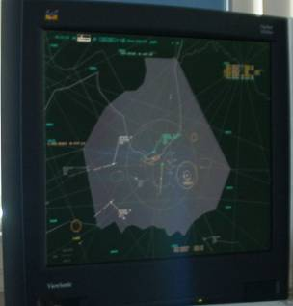
Picture 8, Sector APPROACH

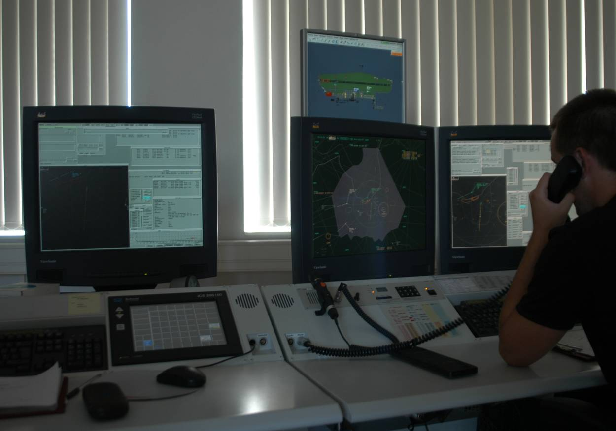

Picture 9, Controller working position

1.2. Injuries to persons

There were no injuries.

1.3. Damage to aircraft

Not damage occurred.

1.4. Other damage

Objects other than aircraft not damaged.

1.5. Personnel information

Air traffic controller: Female
Ratings: All necessary ratings were valid (Rating Certificate to Air Traffic Controller Licence valid);

Captain of BOEING 735: 37 years old;
Ratings: All necessary ratings were valid;
Total flight experience - 19000 hours; Total hours last 28 days - 93hrs 03min;
Flight time last 24 hours - 5hrs 03min; Flaying hours in incident day - 05hrs 03min;
Rest period 48h before flight - 36,78hrs; Flight experience on aircraft Boeing 735 - 3000 hours.

First officer of BOEING 735: 39 years old;
Ratings: All necessary ratings were valid;
Total flight experience - 1016 hours; Total hours last 28 days - 93hrs 33min;
Flight time last 24 hours - 7hrs 53min; Flaying hours in incident day - 05hrs 03min;
Rest period 48h before flight - 36,50hrs; Flight experience on aircraft Boeing 735 - 208 hours.

Captain of AIRBUS A-320
Ratings: All necessary ratings were valid;
Total flight experience - 11200 hours; Total hours last 28 days - 81hrs 35min;
Flight time last 24 hours - 4hrs 53min; Flaying hours in incident day - 6.6hrs;
Rest period 48h before flight - 16hrs 15min; Flight experience on aircraft AIRBUS A-320 - 1200 hours.

First officer of AIRBUS A-320
Ratings: All necessary ratings were valid;
Total flight experience - 3780 hours; Total hours last 28 days - 52hrs 20min;
Flight time last 24 hours - 0hrs 0min; Flaying hours in incident day - 6.6hrs;
Rest period 48h before flight - 48 hours; Flight experience on aircraft AIRBUS A-320 - 60 hours.

1.6. Aircraft information

Aircraft type - Boeing 737-500; Registration - YL-BBA; Owner of aircraft - „Air Baltic Corporation”; serial No.24646; TOW - 56000kg; Engines - CFM56-3C-1;
Aircraft type - Airbus A-320-211; Registration - YL-BCB; Owner of aircraft - „LatCharter”; serial No.726; TOW - 73500kg; Engines - CFM56-5A1.

1.7. Meteorological information

Weather conditions on July 25, 2008 (16:50 -18:20 UTC) in the Riga international airport:

METAR EVRA 251650Z 35013KT CAVOK 22/15 Q1019 N0S1G=
METAR EVRA 251720Z 35011KT CAVOK 21/15 Q1019 NOSIG=
METAR RVRA 251750Z 35010KT CAVOK 21/15 Q1019 NOSIG=
METAR EVRA 251820Z 35008KT CAVOK 20/15 Q1020 NOSIG=
TAF EVRA 2514007.251S24 3601.6KT CAVOK=

1.8. Aids to Navigation

The flights were under Radar control. Air Traffic Control System ATRACC+ (Manufacturer, s serial No N SI P 101.1) is an ATM system for area, approach and tower Control of the Riga FIR. From a functional point of view, the system consists of two main components: a Primary System, and a Radar Bypass System. A Primary System providing multi radar tracking advanced flight plan data integration, predicted flight trajectories, OLDI (On-Line Data Interchange), silent co-ordination and paperless HMI. A Radar Bypass System for use if the primary system should fail. The Radar Operator Workstation is common for the Primary System, and the Radar Bypass System.

Four main functional blocks are defined:
- The Flight Plan Data Management block
- The ATC Functions
- The Support Functional block and the ATC-Simulator

Flight Plan Data Management ATC Functions
Flight Data Assistant HMI

FPL Handling
Controller HMI
AIS
RDP
ATC Tools
Trajectory Calculation
Route Analysis
RPL Handling

RPL
Flight Data Assistant HMI
FPL Handling
Controller HMI
AIS
RDP
ATC Tools
Trajectory Calculation
Route
Analysis
RPL Handling

RPL

FPL

Picture 10

The distinct border is between the Flight Plan Data Management block and the ATC Functional block.
A Flight Data Assistant, (FDA) is working with Repetitive Flight Plans, (RPLs) and passive Flight Plans, (FPLs) in the Flight Plan Data Management block while the ATC controller is working with active FPLs in the ATC Functional block. Flight plan data management is available at flight data assistant working positions. The Flight Data Assistant HMI has efficient support for editing, browsing, queue handling and specification of complex search criteria.
RPLs can be searched, created, modified and deleted manually, but also automatically based on airline time schedules on data media. FPLs are normally created automatically from RPLs or received from AFTN. They can also be searched, created, modified and deleted manually. Received AFTN and OLDI messages are processed and checked automatically and produce updates of concerned FPLs. Billing data is automatically submitted to external systems at FPL termination. For RPLs and FPLs both, route analysis is done and route details are examined against the local airspace structure for compliance with ICAO rules.
The airspace structure is defined by means of system parameters. ATC functions are available at controller working positions. Controller interaction with flights is performed through extensive use of lists and flight symbols. A trajectory describing the flight path in airspace is calculated with consideration to aircraft performance characteristics and current weather data. The trajectory’s coverage of ATC sectors determines the distribution of flight data to working positions. Data from PSR and SSR radar stations is processed by means of an advanced centralized true multi-radar tracker. The resulting system tracks are associated with FPLs. Flight symbols comprising surveillance and flight plan information are presented to controllers.

1.9. Communications

APP controller provides ATS using VHF radio stations on frequency 127.3 MHz, ATS system “ATRACC+” and pilot reports. For the investigation the ATCO console recordings on the frequency 127.3 MHz was used. The quality of the recordings was good.
Co-ordination with adjacent ACCs shall be performed by means of available communication facilities.
Co-ordination within Riga FIR shall be performed using available “ATRACC+” system functionality.
ATCO1 and crew members of BTI6C4 as well as LTC306 have used standard phraseology and there had not principal errors in the used phraseology.
Communication Transcript there was not essential inaccuracies in radio communications on all sides.
Within the framework of Quality Management System (QMS) Riga ATCC are worked out “Regulations and procedures on ground-to-air radiotelephony” PR-GSV/AvDN-01/ 2 which are applicable for the provision of Air Traffic Services within RIGA FIR/UIR. The provisions of this document are based on ICAO SARPs, ICAO Regional procedures. The provisions of this document are mandatory for ATS personal conducting direct ground-to-air radio communications.

1.10. Aerodrome information

The airport did not have any significance for the incident.

1.11. Flight recorders

The incident reconstruction was based on the radar records and voice communications transcript between controller ATCO1 of Riga ATCC and aircrafts crew members as well as available FDM data.

1.12. Wreckage and impact information

Not damage.

1.13. Medical and pathological information

Not relevant to this incident.

1.14. Fire

There was no fire.

1.15. Survival aspects

Not necessity to survey.

1.16. Tests and research

Were not performed.

1.17. Organizational and management information

According to Law on Aviation of the Republic of Latvia the authority responsible for activities of the utilizations of the airspace of the Republic of Latvia for civil and military needs and the flight of aircraft shall be controlled by the Air traffic control unit - the State Joint-Stock Company – “Latvijas Gaisa Satiksme - LGS” which is the air traffic service provider in the Republic of Latvia. Air traffic control has provided in the airspace of Riga FIR, by Latvian Air Navigation Services (LGS) staff (See Picture 15).

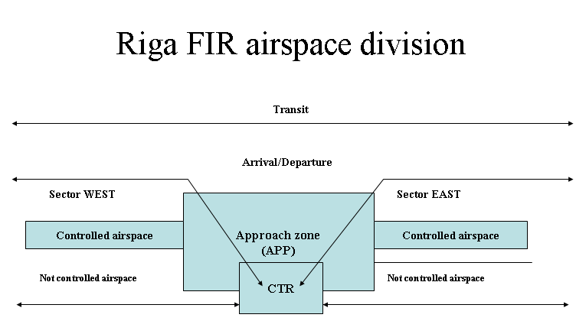

Picture 11

For the ATS provision the following areas of responsibility (AoR) are established within Riga FIR/UIR: Sector EAST, Sector SOUTH, Sector NORTH, Riga TMA, Riga CTR, Liepaja TMA, Liepaja CTR, Ventspils TIA and Ventspils TIZ. Sector WEST provides ATS within NORTH AoR, SOUTH AoR, Liepaja TMA AoR, and Ventspils TIA AoR. Riga APPROACH provides services within Riga TMA AoR according to the existing classification.
Within Riga TMA AoR (Sector A) ATS is provided above altitude 3000 FT MSL till FL285, FIS is provided at and below altitude 1500 FT MSL. Within Riga TMA AoR (Sector B) ATS is provided above altitude 1500 FT MSL till 3000 FT MSL, FIS is provided at and below altitude 1500 FT MSL (See Picture 12).
Riga APPROACH could be operational or not operational. Riga APPROACH provides ATS within Riga TMA AoR when it is operational. The Riga TMA AoR could be transferred to Sector EAST.
Riga APPROACH closing procedures are following:
- to receive the instruction from OSUP (Riga) to close Sector;
- to transfer Riga TMA AoR to Sector EAST;
- to control the acceptance of the responsibility;
- to logout at CWP.

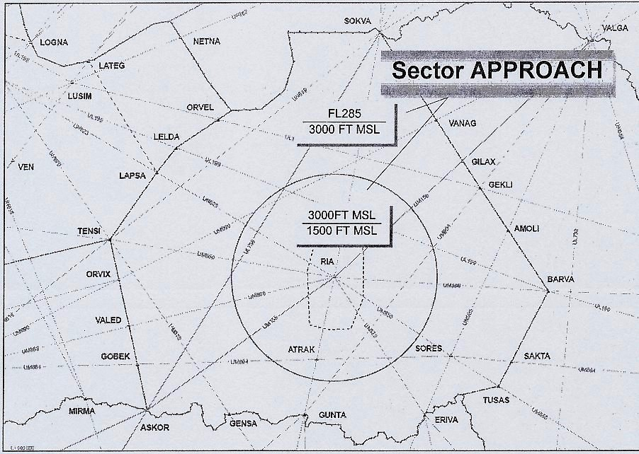

Picture 12, AREA OF RESPONSIBILITY Riga TMA AoR
(Sector B)
Circle radius 25 NM
Riga TMA AoR (Sector A) (except Riga CTR AoR)

Riga APPROACH opening procedures are following:
- to receive the instruction from OSUP (Riga) to open Sector;
- to login at CWP with the appropriate Operational Role;
- to receive proposal and to accept the responsibility over Riga TMA AoR from the previous sector EAST.

According to APPROACH Sector controller technological procedures DI-GSV/GSVC-01 of Riga ATCC, working position of the sector APPROACH is shareable between a controller with operational role “APPROACH Executive” and a controller with operational role “APPROACH Planner” appointed by the Watch Supervisor from a controller during the highest flight intensity hours. When traffic intensity permits one Controller may provide the service at APPROACH Sector with operation role “APPROACH Executive”.
A controller with operational role “APPROACH Executive” must:
- Issue ATC clearances, instructions and information to the crew using standard phraseology;
- Receive the pilot's reports in respect of flight progress;
- Inform the crew regarding their position and traffic situation (when required);
- Inform the crew regarding meteorological conditions (when required);
- Provide the crews with any important information related to the conditions on the route or destination/alternative aerodromes (if any);
- Conduct aircraft identification and continuously control the traffic within the area of responsibility;
- Provide established separation minima;
- Perform silent traffic coordination between Riga ATCC sectors;
- Provide the crew with any possible assistance in case of abnormal/emergency situation.

Sector APPROACH can be amalgamated with Sector EAST. ATCO provides ATS using On Job Instructions for the sectors EAST+APPROACH (DI-GSV/GSVC-08) and VHF radio stations on frequencies 133,2 MHz and 127,3 MHz with active “Couple” mode of VCMS. Amalgamation or separation of the Control Sector should be done, when decision in taken by OSUP.
Within Riga TMA vertical separation is carried out according to ICAO Annex 2, “Table of Cruising levels 3a” and applied between FL 290 and FL 410 inclusive - 1000ft (300m).
Horizontal separation (radar separation) if double SSR coverage is provided between identified, controlled aircraft not less than 5NM.
According to technological procedures of Riga ATCC at the start of the shift APP controller has to login in the ATRACC+ system. The start of the shift is determined by the login time. All temporary substitutions shall be performed via login procedure. Substitution of the controller is determined by the operational or the administrative supervisor. A temporary leaving of the working position during the shift requires a substitution.

Transfer of control with Riga Tower
Responsibility for arriving landing aircraft is handed over by the APP controller to the TWR controller considered that aircraft will be able to complete its approach:
- If aircraft is using ILS or LLZ - when reported "ESTABLISHED ON ILS" or "ESTABLISHED ON LOCALISER" from the distance of 12,5 NM but not closer than 4,0 NM from THR 18/36;
- If this criterion is not fulfilled request aircraft its readiness to continue ILS or LLZ approach and;
- If ready, give instruction to report "ESTABLISHED ON ILS" or "ESTABLISHED ON LOCALISER"to TWR;
- If not, break off ILS or LLZ approach and give appropriate instructions.

Before the transfer of radar control to Riga TOWER, APP controller should adjust speeds of successive aircraft to ensure the distance on final is not less than 5 NM.

Provision of separation between aircraft
In all cases when arriving traffic has not crossed altitude 2500 ft and it is handed over to the TWR controller, the APP controller is responsible for separation provision for all other traffic within Riga TMA AoR.
For traffic at altitude 2500 ft within Riga CTR, APP controller shall inform TWR controller about traffic, TWR controller provides separation for all other traffic within Riga CTR AoR and APP controller provides separation for all other traffic within Riga TMA AoR.
For traffic below altitude 2500 ft and above altitude 1500 ft within Riga CTR TWR controller shall inform APP controller about traffic, APP controller provides separation for all other traffic within Riga TMA AoR andTWR controller provides separation for all other traffic within Riga CTR AoR.

Radar vectoring procedures
The information presented on a radar display may be used to perform the following additional functions in the provision of approach control service:
- Provide radar vectoring of arriving traffic on to ILS or LLZ approach, entering altitude (FAP) 4000 FT, 2500 FT or 1500 FT for the purpose of establishing an expeditious and efficient approach sequence;
- Provide radar vectoring of arriving traffic on to VOR approach, entering altitude (FAF) 4000 FT and 2500 FT;
- Provide radar vectoring of arriving traffic to a point from which a visual approach can be completed.

Radar vectors should be given and descent clearance should include an estimate of track distance to touchdown. The minimum distance to touchdown is determined taking into account distance from FAP (FAF) to touchdown, distance (length) of intermediate approach segment and intercept angle with ILS or LLZ (VOR).

Type of Approach | Glide path  entering altitude  (feet) | Intercept  angle (degrees) | Minimum distance to  touchdown n  (NM)
ILS RWY 18/36,  LLZ RWY 18/36 | 1500 | 0-15°  16-30°  31-60° | 6,0  6,5  7,0
 | 2500 | 0-15°  16-30°  31-60° | 9,1  9,6  10,1
 | 4000 | 0-15°  16-30°  31-60° | 13,9  14,4  14,9

Table 2, Minimum distances to touchdown

Short-term Conflict Alert Procedures
The generation of Short Term Conflict Alerts is a function of an ATC radar data processing system. If the distance between the three-dimensional position of two aircraft is predicted to be reduced to less than the defined applicable separation minima within a specified time period, the visual alert will be generated to the radar controller within whose jurisdiction area the aircraft is operating. All types of flight transponder-equipped aircraft with Mode C are eligible for generation of STCA.

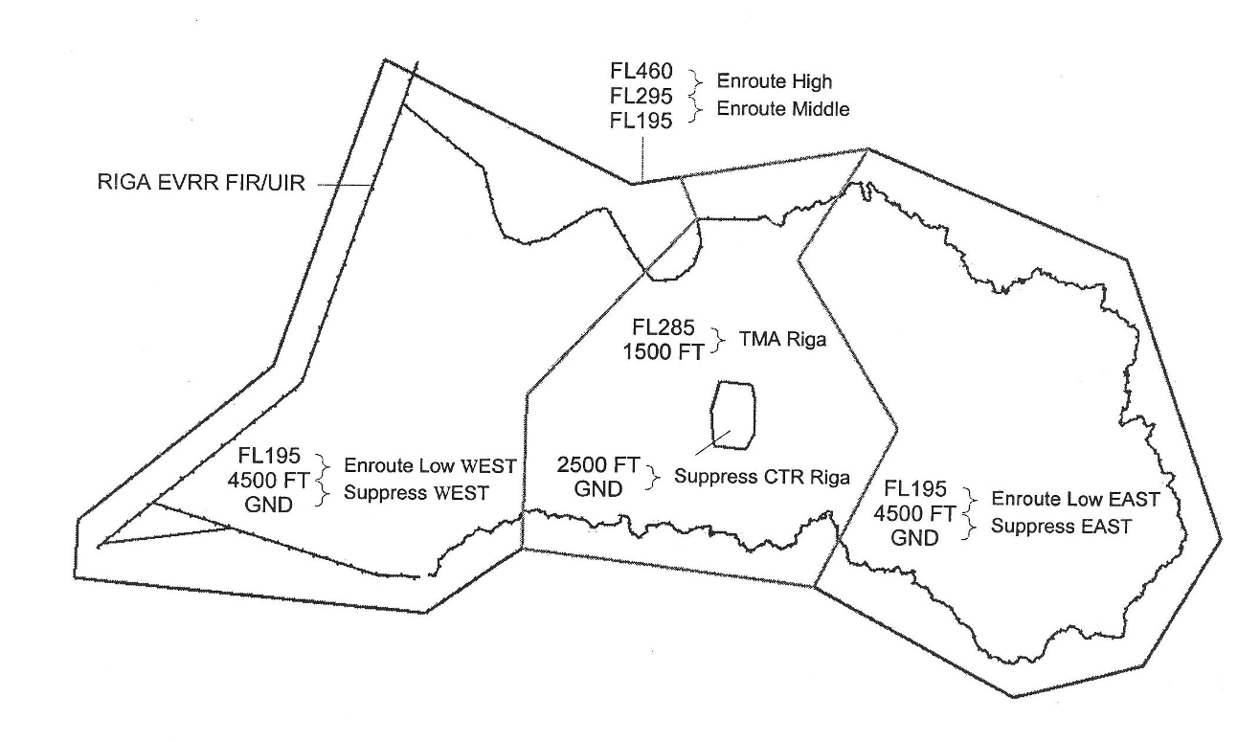

Picture 13, STCA WORK AREAS

The parameters for generation of STCA alert and alert warning time (Table 3):

Item Area | Look Ahead Time¹ | Hsep²  (NM) | Vsep³  (feet) | Hsep⁴ ATC  (NM) | Vsep⁵ ATC  (feet)
Enroute High  Above FL295 | 120 sec | 4,2 | 870 | 5,0 | 1000
Enroute Middle  FL195-FL295 | 120 sec | 4,0 | 800 | 5,0 | 1000
Enroute Low East  4500FT-FL195  GND - 4500 FT (suppress) | 90 sec | 4,0 | 800 | 5,0 | 1000
Enroute Low West  4500FT-FL195  GND - 4500 FT (suppress) | 90 sec | 4,0 | 800 | 5,0 | 1000
Tma Riga  1500FT-FL255  GND - 1500 FT (suppress) | 90 sec | 4,0 | 700 | 5,0 | 1000
Ctl Riga  GND - 2500 FT (suppress) | - | - | - | - | -

¹- The maximum predicted time;
²- The minimum horizontal separation between ACFT;
³- The minimum vertical separation between ACFT;
⁴- The horizontal ATC separation Standard used between ACFT;
⁵- The vertical ATC separation Standard used between ACFT.
In the event an STCA generated in respect of controlled flights, the controller shall without delay take action to ensure that the applicable separation minimum will not be infringed.
Following the generation of an STCA, only in the event that a separation minimum was infringed, controllers must fill out “ATS Occurrence Reporting Form”.

1.17.1. Quality management system

Quality Management System (hereinafter QMS) document structure and hierarchy is comprised of Quality Handbook and other subordinated document categories: procedure’s description, technological instructions, flow charts, official instructions, labor instructions and quality records.

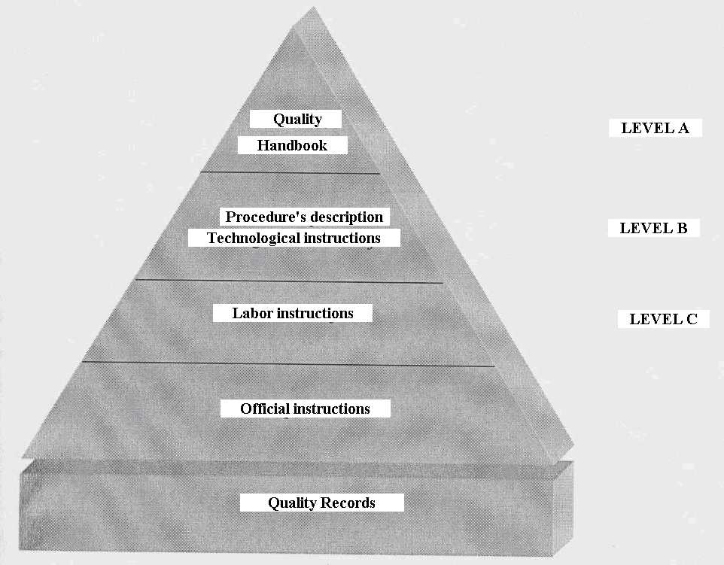

Picture 14

Picture 14 shows LGS document structure. On the top of document hierarchy is Quality Handbook, management document of higher level. Moving from the top of this structure downward, documents become more specific in their purpose and scope, and document content becomes increasingly detailed.
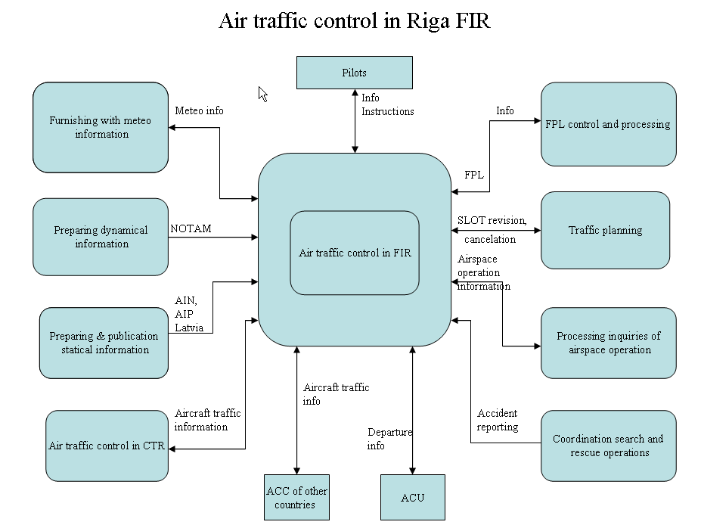

Picture 15

Performance criterion | Measurement | Sort of information/data
Safety | Number of pilot’s complaints of low separation interval | Analysis of radiotelephony records  Results of customer’s opinion poll
Safety | Coefficient of safety | Yearly estimation
Safety | Rating of IATA assessment | IATA Annual Report
Regularity | Number pilot’s complaints of delay due to controller’s | Analysis of radiotelephony records  Results of customer’s opinion poll
Regularity | Number of pilot’s complaints about not timely given information | Analysis of radiotelephony records  Results of customer’s opinion poll
Accuracy of information | Number of complaints of distortion information | Analysis of radiotelephony records  Information from other ACC  Information from airlines  Results of customer’s opinion poll

Table 4, Air traffic control performance criterions and measurement in Riga FIR

According to Quality Handbook chapter “Organizational structure, distribution of responsibilities and authorities” the person in charge for resolving all problems relating to air traffic control services safety, quality, documentation and prevention is Head of ATCC Department. Head of ATCC Department is responsible for making decisions in case of inadequate services in the field of air control.
Quality system manager is responsible:
- Quality system maintenance;
- Preparing information materials for quality management reports, it planning and organization;
- Internal audit planning and organization;
- Verification the developed and implemented corrective actions as result of internal audit;
- Planning and organization of quality management reports.

The State Joint-Stock Company - “Latvijas Gaisa Satiksme - LGS” must ensure all necessary resources for maintenance Quality Management System according to requirements Latvian and international standard LVS EN ISO 9001:2000. Person in charge for making resources available is Chairman of the Board.

1.17.2. Safety Management System

In accordance with EUROCONTROL Safety Regulatory Requirement ESARR 3 „USE OF SAFETY MANAGEMENT SYSTEMS BY ATM SERVICE PROVIDERS ATM” service-providers shall have in place a safety management system (hereinafter SMS).
SMS has embraced air traffic control services provider - the State Joint-Stock Company - “Latvijas Gaisa Satiksme - LGS”. SMS is founded on “cooperation approach” according to terms of EUROCONTROL document “Safety and Quality Relationships Guidelines”. Because there has established, operated and has in continuous improving process QMS (ISO 9001:2000), SMS has integrated taking into account special requirements of SMS and Commission Regulation (EC) No 2096/2005 of 20 December 2005 laying down common requirements for the provision of air navigation services. For implementation, maintenance and monitoring SMS in the State Joint- Stock Company “Latvijas Gaisa Satiksme - LGS” has established as obligatory joint Safety/Quality Management Systems main procedures and Handbooks.
According to “Latvijas Gaisa Satiksme - LGS” safety responsibility terms - everyone has an individual responsibility for their own actions and managers are responsible for the safety performance of their own organizations.
In accordance with SMS Handbook the State Joint- Stock Company - “Latvijas Gaisa Satiksme - LGS” main safety management principles are:
- Safety achievement;
- Safety assurance;
- Safety promotion.

Within the framework of SMS has established risk assessment and mitigation, details of risk assessment has described in procedure “Hazards identification and risk assessment”.
Safety Occurrences assessment has established and described in procedure “Dealing with nonconformities, corrective and preventive actions”.
Safety objectives based on risk have established in terms of the hazards maximum probability of occurrence, derived both from the severity of its effect and from the maximum probability of the hazards effect.
Severity Classes 1, 2, 3, 4, 5 have determined in accordance with ESARR 4 Severity Classification Scheme in ATM.
At present in Europe the quantitative definitions have calculated only for Severity Class 1 as ECAC Safety Minimum of a maximum tolerable probability of ATM directly contributing to an accident of a Commercial Air Transport aircraft of 1,55 10⁻⁸ accidents per Flight/Hour or of 2,31 10⁻⁸ accidents per flight.
For Severity Classes 2, 3, 4, 5 quantitative definitions to be determined at national level based on past evidence on numbers of ATM related incidents.
The Safety Manager is responsible for SMS performance. Department managers are responsible for immediately performance appropriate measures in subordinate departments in case when risk has indentified and appear necessity to implement improvements and corrective action taken.

1.18. Additional information

Not applicable.

1.19. Useful or effective investigation techniques

The incident has been investigated in accordance with Annex 13.

2. ANALYSIS

2.1. General

The investigation of the serious incident – infringement of separation standards between airBaltic Boeing 735, registered YL-BBA, flight BTI6C4 and Latcharter Airbus A320, registered YL-BCB, flight LTC306 was orientated essentially around the following questions:
- Had Air Traffic Control Services unit procedures, operations and instructions an influence on the incident?
- Had Approach Sector controller actions an influence on the incident?
- What kind of the human errors had influence on the incident?

The analysis activities of airBaltic Boeing 735 flight BTI6C4 and LatCharter Airbus A320, flight LTC306 is build on review of crew radio communications transcript with ACC controller, interview with ATC Controller involved, radar recording, air operation service instructions, Quality Management System and Safety Management System.

2.2. Explanation of the situation

At 20:26:25 in the controlled airspace of Riga FIR/ TMA, APP controlled airspace has not been very high traffic activity, there were 5 aircraft under service. Therefore one Controller had provided the service at APPROACH Sector with operation role "APPROACH Executive" as well as in this case she carried out the duties of “APPROACH Planner” accordingly terms of technological procedures DI-GSV/GSVC-01 of Riga ATCC. During incident Sector Approach did not amalgamate with Sector EAST.
The incident occurred within the Riga ATCC in Class C controlled airspace (See Table 5), were operating under IFR and were on radio contact with Riga TMA APPROACH Sector on VHF frequency 127,3 MHz. The classifications adopted by ICAO are: Class C - IFR and VFR flights are permitted, all flights are provided with air traffic control service and IFR flights are separated from other IFR flights and from VFR flights. VFR flights are separated from IFR flights and receive traffic information in respect of other VFR flights.

LATVIA
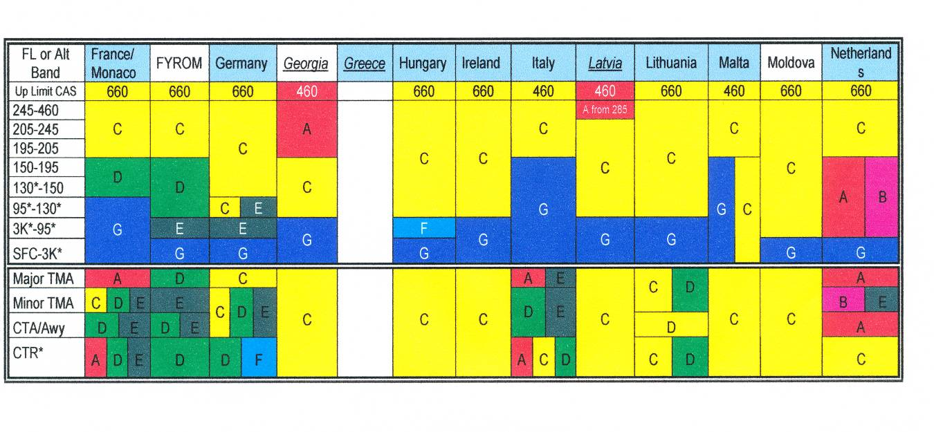
Table 5

Before incident both aircrafts flew at transversally direction - BTI6C4 was descending on FL 130, LTC306 was descending on FL 110 and had radar contact.

2.3. Air Traffic Control Services procedures, operations and instructions, air traffic controller actions.

The horizontal radar separation minimum within Riga TMA, in accordance with technological procedures DI-GSV/GSVC-01 of Riga ATCC, if double radar coverage is provided between both identified, controlled ACFT shall be 5.0 NM (9.3 km) and vertical separation is carried out according to ICAO Annex 2 Table of Cruising levels.
According to terms of Doc 4444-RAC/501 “RULES OF THE AIR AND AIR TRAFFIC SERVICES” ACFT approach speeds should closely monitored by the controller and when necessary adjusted so as to ensure that separation is not reduced below the minimum.
The chain of events that led to this incident was following:
At 20:26:25 BTI6C4 contacted Riga Approach controller and had instructed to descend to FL 60 for radar vectoring of arriving on to ILS approach to RWY36. There were not unsafe situation when an avoidance action would have been appropriate.
At 20:27:02 BTI6C4 reported “Air Baltic 6C4 ready for short final”, i.e. the crew requested to perform visual approach.
Accordingly procedures of air navigation services an IFR flight may be cleared to execute a visual approach provided that the pilot can maintain visual reference to the terrain and the reported ceiling is at or above the approved initial approach level for the aircraft so cleared or the pilot reports at the initial approach level or at any time during the instrument approach procedure that the meteorological conditions are such that with reasonable assurance a visual approach and landing can be completed. Separation shall be provided between an aircraft cleared to execute a visual approach and other arriving and departing aircraft.
Because APP controller No1 for landing planned LTC306 approaching from Vilnius FIR BTI6C4 was instructed that it will be No3 to land, must expect ILS approach to RWY 36 and reduce speed. On request of controller BTI6C4 declared that its speed is 280 kt now and was instructed to reduce speed to 250kt.
At 20:30:46 LTC 306 contacted Riga Approach controller and declared descending to FL 110 to reporting point on request “GUNTA” (N56:22:17; E023:45:2o) and was cleared by controller after Standard Arrival Route-Instrument (STAR) RWY 36 “GUNTA 3C” (Route designator UM857) to continue to descend to FL 100 as well as requested to declare LTC 306 its indicated speed.

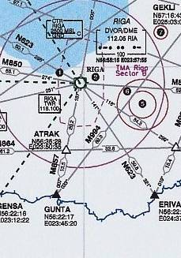

Picture 16

At 20:31:06 LTC 306 declared: “Indicated speed 300, after GUNTA Gunta 3C” whereupon controller issued instruction for LTC 306: “Latcharter 306 copied that, keep speed 300 knots and report when ready reducing to 250”. The crew of LTC 306 read back instruction.
At 20:31:45 controller instructed BTI6C4:“Air Baltic 6C4 speed 220 knots” and the crew read back instruction.
At 20:32:21 controller issued instruction for LTC 306: “Latcharter 306 continue descend to altitude 2500FT, QNH 1020”.
Up to now controller tried to reduce speed of both aircraft and held a view that that aircraft will pass each other and the regulatory radar separation will guarantee.
At 20:33:12, seeing that speed reducing did not hold a hope that aircraft will pass without infringement of separation standards, controller tried to turn BTI6C4 10 degrees right for decreasing lateral interval between aircraft issuing following instruction: “Air Baltic 6C4 right, heading 085”. The crew of BTI6C4 read back instruction.
At 20:33:46 controller issued clearance for LTC 306: “Latcharter 306 cleared ILS approach RWY 36, report established localizer”. The crew read back instruction and after a while at 20:34:57 reported: “Riga Approach, Latcharter 306 decreasing airspeed to 250” that was copied by Riga Approach controller.
Controller’s action turning BTI6C4 right did not gave required result and both aircraft were located on approximately equal flight level. For saving the situation descend of BTI6C4 was halted on FL 70 issuing instruction: “Air Baltic 6C4 recleared to descend FL 70 initially” as well as for LTC 306 was issued instruction: “Latcharter 306 turn right 10 degrees, report new heading”, whereupon the crew of LTC 306 copied instruction and reported that its new heading will be 020 degrees and controller issued following instruction for LTC 306: “Latcharter 306 copied, on heading 020 still cleared ILS approach RWY 36”.
At 20:35:57 LTC 306 read back controller instruction – “Cleared for ILS approach RWY 36 on present heading, Latcharter 306”.
Controller reported:” Latcharter 306 on your heading …”, whereupon the crew answer was following – “On heading Latsharter … (unreadable)… congratulations ….?”
At 20:36:04 STCA warning generated and after a while at 20:36:15 controller instructed LTC306- “Latcharter 306 expedite vacating FL 70”.
Because vertical speed of LTC 306 was about 1000 Ft/min (speed not set by controller) and probably controller calculated that aircraft will take FL60 up to standard time, but due to decreasing vertical speed for a while at the moment of crossing FL6 separation was lost.

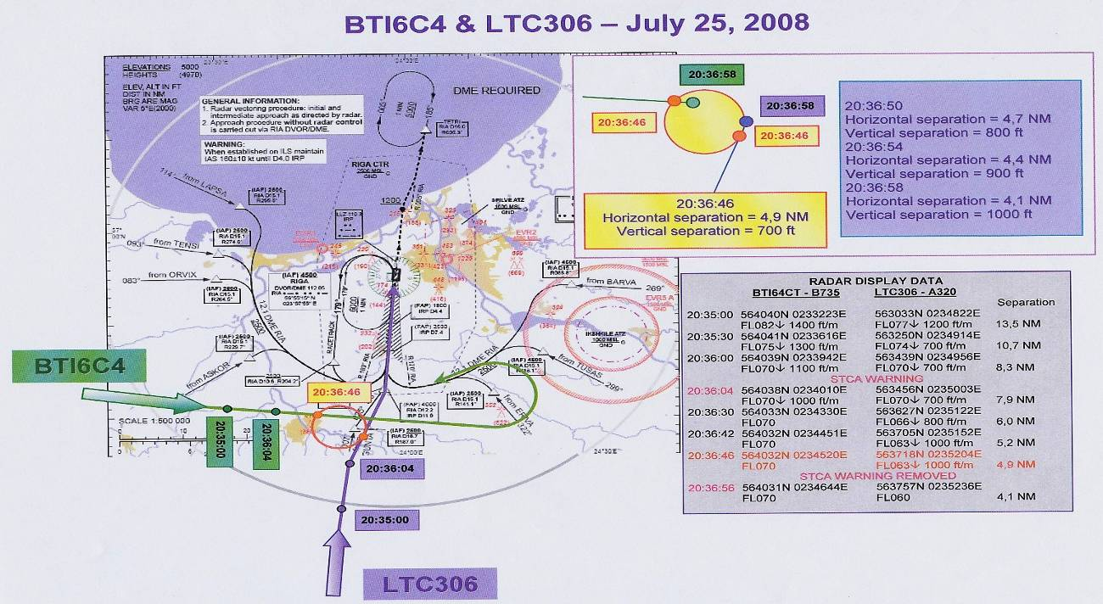

Picture 17

The conflicting traffic was in sight to each other before incident, so when at 20:36:29 controller informed BTI6C4 – “Air Baltic 6C4, No1 traffic is now your at 2 o’clock from left to right, separation 6 miles, now crossing FL 65, descending” the crew of BTI6C4 reported: ”Copied 6C4, he is from the right side”.
Minimal distance between aircraft was 4,1NM. At the moment of incident at 20:36:46 vertical separation was 700 FT, horizontal separation 4,9NM.
Accordingly to air control unit Air Traffic Control Services procedures, operations and instructions the investigation had stated following:
- Procedures, operations and instructions of air control unit - the State Joint Stock Company Latvijas Gaisa Satiksme (LGS) have complied with the requirements of ICAO Doc 4444-RAC/501 “PROCEDURES FOR AIR NAVIGATION SERVICES, RULES OF THE AIR AND AIR TRAFFIC SERVICES” as well as has a quality management system which covers all air navigation services it provides;
- The scope of the Air Traffic Control Services procedures, operations and instructions had not essential influence to incident.

According to EUROCONTROL guidance material (ESARR 2 Guidance to ATM Safety Regulators, EAM 2/GUI 1, Severity Classification Scheme for Safety Occurrences in ATM, Edition 1.0, edition date 12-11-1999), see tables 6, 7, this incident is classified as Major Incident -B -Loss of separation (separation higher than half the separation minima/e.g., 4NM) which is not fully under ATC control.
Taking into account the Severity Classification Scheme that specifies five qualitative frequency categories this incident is classified as B3.

SEVERITY | A | Serious incident | A1 | A2 | A3 | A4 | A5
SEVERITY | B | Major incident | B1 | B2 | B3 | B4 | B5
SEVERITY | C | Significant incident | C1 | C2 | C3 | C4 | C5
SEVERITY | D | Not determined | D1 | D2 | D3 | D4 | D5
SEVERITY | E | No safety effect | E1 | E2 | E3 | E4 | E5

1 | 2 | 3 | 4 | 5
Very Frequent | Frequent | Occasional | Rare | Extremely rare
FREQUENCY

Table 6, Severity Classification Scheme for Aircraft Incidents

FREQUENCY | DEFINITION
Extremely rare | Has never occurred yet throughout the total lifetime of the system.
Rare | Only very few similar incidents on record when considering a large traffic volume or no records on a small traffic volume.
Occasional | Several similar occurrences on record - Has occurred more than once at the same location.
Frequent | A significant number of similar occurrences already on record - Has occurred a significant number of times at the same location.
Very Frequent | A very high number of similar occurrences already on record - Has occurred a very high number of times at the same location.

Table 7, Definitions of Accident/Incident Frequency
2.4. Underlying Human Factors problems associated with incident

For revealing causation of this incident it was put into practice the taxonomy of the Human Factors Analysis and Classification System that describes the human factors that contribute to an incident. It is based on a sequential or chain-of-events theory of accident causation. The human contribution don’t build on the person approach, that focuses on the errors and violations of individuals but is based on the system approach, that traces the causal factors back into the system as a whole. The investigation view is not that Human Error is a cause of incident but that Human Error is a symptom of trouble deeper inside a system. The classification system has four levels, each of which influences the next level. These four levels are called:
- organizational influences;
- unsafe supervision;
- preconditions for unsafe acts;
- unsafe acts of operators.

Human factors played the major role in the cause of this incident and this further reinforces the requirements to examine the role of human factors in the Air Traffic Control.

2.5. Unsafe acts of operators

The unsafe acts can be loosely classified into two categories: errors and violations.

I. Errors
During investigation here were fixed following errors that ultimately led to the serious incident:

1. Skill-Based error
- Air traffic controller on duty of APP Sector failed to take into account all factors for correctly evaluation of approaching aircraft that could to have an influence on guarantee the regulatory radar separation.

2. Decision errors
- Poor decision of air traffic controller didn’t set vertical speed (descending rate) for aircraft LTC306.

II. Violations
- Investigation didn’t reveal any violations such as willful disregard for the rules and regulations that govern safe flight.

2.6. Preconditions for unsafe acts

Two major unsafe subdivisions of unsafe conditions are developed:
- substandard conditions of operators;
- substandard practices of operators.

I. Substandard conditions of operators
Investigation didn’t reveal any substandard conditions of operators such as adverse mental states, physiological states as well as physical/mental limitation.

II. Substandard practices of operators
Generally speaking, the substandard practices of operators can be summed up in two categories:
- resource mismanagement;
- personal readiness.

Within the context of this incident this includes coordination both within and between aircraft with air traffic control facilities. There not revealed poor coordination among aircrew and air traffic controller.
Personal readiness failures occur when individuals fail to prepare physically or mentally for duty. Within the context of this incident there not revealed personal readiness failures when operators fail to prepare physically or mentally for duty.

2.7. Unsafe supervision

Exist four categories of unsafe supervision:
- inadequate supervision;
- planned inappropriate operations;
- failure to correct a known problem;
- supervisory violations.

Within the context of this incident there was not reveled any inappropriate supervision of operations.

2.8. Organizational factors influencing incidents

Fallible decisions of upper-level management directly affect supervisory practices, as well as the conditions and actions of operators. The most elusive of latent failures revolve around following issues of organizational influences:
- Resource management;
- Organisational climate;
- Operational process.

Within the context of this incident there were not find lack of human resources, budget resources, deficient planning, as well as were not find any adversarial, or conflicting, or when they are supplanted by unofficial rules and values and confusion abounds that could to have influence on creation of this serious incident.

3. CONCLUSIONS

During process of investigation were made the following conclusions:

3.1. Findings

- Authentic information about occurrence was received from the duty officer of ARCC Riga, a structural part of LGS responsible for co-ordination of SAR operations within Riga FIR. According to Annex 13 to the Convention on International Civil Aviation given occurrence can classify as serious incident;
- At the time of the incident the traffic was handled by an air traffic controller of APP sector with operational role “APPROACH Executive” as well as carried out the duties of “APPROACH Planner”;
- The safety of BTI6C4 and LTC306 was seriously compromised by the failure of the Approach Controller to maintain a safe separation between the two aircraft. There were no electronic/technical reasons which contributed to this failure. This was a human error;
- The air traffic controller held valid licence and ratings and was qualified and current at the position;
- Controller did not make actions to change descending rate of LTC306 to FL 60;
- ATC controller was self-reliant that situation is safe as a result lost of situation awareness;
- The incident occurred within the Riga TMA;
- At the time of incident in the APPROACH Sector was low traffic intensity;
- Both aircrafts involved were flying in Class C controlled airspace;
- The aircrafts were arriving to Riga International airport;
- Both aircrafts involved were operating on IFR flight plans;
- The flights were under Radar control;
- Air Traffic Control System ATRACC+ (Manufacturer, s serial No N SI P 101.1) is an ATM system for area, approach and tower Control of the Riga FIR;
- Within Riga TMA vertical separation is carried out according to ICAO Annex 2 Table of Cruising levels 3a -1000ft (300m);
- Horizontal separation (radar separation) if double SSR coverage is provided between identified, controlled aircraft not less than 5NM;
- According to EUROCONTROL guidance material (ESARR 2 Guidance to ATM Safety Regulators this incident is classified as Major Incident;
- At the time of incident Visual Meteorological Conditions (VMC) prevailed;
- Both aircrafts involved were in radio contact with Riga ATCC;
- The radio communication between the aircrafts and ATCO1 Riga Approach Sector was held on the frequency 127,3 MHz in English;
- Investigation didn’t reveal any violations such as willful disregard for the rules and regulations that govern safe flight;
- The incident was reported according to the MOR System.

3.2. Causes

Causes of the serious incident - infringement the separation minima between Air Baltic Boeing 735, registered YL-BBA, flight BTI6C4 and LatCharter Airbus A320, registered YL-BCB, flight LTC306, were the following:

3.2.1. Root Cause
The source or origin of an event that played the major role that caused this incident was the fact that the air traffic controller who handled an air traffic due to lack of experience failed to estimate properly time and distance between approaching aircraft to set duly vertical speed rate for descending LTC 306.

3.2.2. Contributing causes
Overfamiliarity of ATC controller that situation is safe as a result loss of situation awareness.

3.2.3. Primary cause
The event after which incident became inevitable.

Controller did not make actions to change descending rate of LTC306 to FL 60 as a result both aircraft approached closely.

4. FLIGHT SAFETY RECOMMENDATIONS

It is recommended that the authority responsible for air navigation services in the Latvian airspace - State Joint Stock Company Latvijas Gaisa Satiksme (LGS):

Recommendation - 1-2009

- should provide additional Human Factors training to all controllers based on ICAO Human Factors digests (Human Factors in Air Traffic Control - Circular 241) and in accordance with EuroControl (EA TCHIP) recommendations;

Recommendation - 2-2009

- should include in training plans of Air Traffic Control Center staff (especially for persons length of service less than 3 years) to practise scenarios, both in theory and in practice, specific controller action in the event of a possible loss-of-separation with particular reference to maintenance the required separation;

Recommendation - 3-2009

- considered opportunity to establish a Critical Incident Response Programme for ATC personnel for decreasing post traumatic stress of staff involved in incidents.

July 10, 2009

Investigator in charge –
Director of Transport Accident
and Incident Investigation Bureau Ivars Alfreds Gaveika

Investigator –
Head of Aircraft Accident
and Incident Investigation Department Visvaldis Trubs

