FINAL REPORT Nr.4-02/5-10/-2/2012

OF THE AIRCRAFT SERIOUS INCIDENT

CABIN DE-PRESSURIZATION of BOMBARDIER DHC-8-400 AIRCRAFT, REGISTRATION YL-BAF ON DECEMBER 5, 2010

The Transport Accident and Incident Investigation Bureau of the Republic of Latvia is a governmental, independent of all aviation authorities’ organization, established by law to investigate and determine the cause or probable cause of accidents and serious incidents that occurred in the civil aviation, as well, if necessary for enhancing flight safety, incidents.
The sole purpose of such investigation is in accordance with Annex 13 of the Convention of Chicago and the Regulation (EU) No 996/2010 of 20 October 2010, establishing the fundamental principles governing the investigation of civil aviation accidents and incidents of the Council of the European Union, to prevent accidents and incidents and, if it appropriate, to issue safety recommendations. The purpose of an investigation conducted under the responsibility of the Transport Accident and Incident Investigation Bureau Republic of Latvia is not to apportion blame or liability.

Address:

58 Brivibas Str., Riga
LV-1011, Latvia
Phone. 67288140,
Fax. 67283339,
E-mail: taiib@taiib.gov.lv

Director of Transport Accident and Ivars Alfreds Gaveika
Incident Investigation Bureau

FINAL REPORT Nr. 4-02/5-10/-2/2012

OF THE AIRCRAFT SERIOUS INCIDENT

CABIN DE-PRESSURIZATION of BOMBARDIER DHC-8-400 AIRCRAFT, REGISTRATION YL-BAF ON DECEMBER 5, 2010

TABLE OF CONTENTS

Synopsis

General information

Investigation

1. FACTUAL INFORMATION

1.1. History of the flight
1.2. Injuries to persons
1.3. Damage to aircraft
1.4. Other damage
1.5. Personnel Information
1.6. Aircraft information
1.6.1. Aircraft doors
1.6.2. Door Seal Pressurization System
1.6.3. Door Warning System
1.6.3.1. Proximity sensors
1.6.3.2. Forward Passenger Door Monitoring
1.6.3.3. Aft Passenger Door Monitoring
1.6.3.4. Pressuarization control
1.7. Meteorological information
1.8. Aids to Navigation
1.9. Communications
1.10. Aerodrome information
1.11. Flight recorders
1.12. Wreckage and impact information
1.13. Medical and pathological information
1.14. Fire
1.15. Survival aspects
1.16. Tests and research
1.17. Organizational and management information
1.18. Additional information
1.19. Useful or effective investigation techniques

2. Analysis

3. Conclusion

3.1. Findings

3.2. Causes

4. Safety Recommendations

Appendices:

1. air Baltic Flight Safety Report No166
2. air Baltic Pilot Flight check Record, ACFT Q400
3. Copy of Air Traffic Controller Rating Certificate to Air Traffic Controller Licence
4. Copy of Flight crew Licence issued CAA of Latvia
5. Copy of Flight crew Licence issued Kingdom of Spain
6. Copies of airBaltic Tech logs
7. Copy of Medical Certificate class I/2 No LVA/MED1-66
8. Copy of Medical Certificate class I&2 No A0040180
9. ATPL/ type rating/training/Skill test and Proficiency check NoE00019338
10. airBaltic Technical Investigation Report
11. Statement of Approval OM-B MEL Temporary Revision No002
12. airBaltic Cabin Safety Report No 769
13. Loadsheet flight BT603 of 05.12.2010
14. Individual Duty plan for PIC
15. Individual Duty plan for FO
16. Aircraft Q400 Time Log No 00971

Abbreviations

CWP - Caution and Warning Panel
PF - Pilot Flying
PIC - Pilot in Command
MEL - Minimum Equipment List
MMEL-Master Mandatory Equipment List
CPCS - Cabin Pressure Control System
PSEU - Proximity Sensor Electronic Unit
CWCP -The Caution and Warning Panel
EFIS - Electronic Flight Info System
EFIS - Electronic Flight Info System
IOP - Input Output Processor
MFD - Multi-Function Display
QRH - Quick Reference Handbook
TTSN - Total Time Since New

Synopsis

Unless stated otherwise the time in this Report is UTC

On Sunday, December 5, 2010 air Baltic aircraft Dash Q-400, registration YL-BAF was on a scheduled passenger service, flight BT-603 from Riga International airport (EVRA), Latvia to Brussels International airport (EBBR), Belgium.

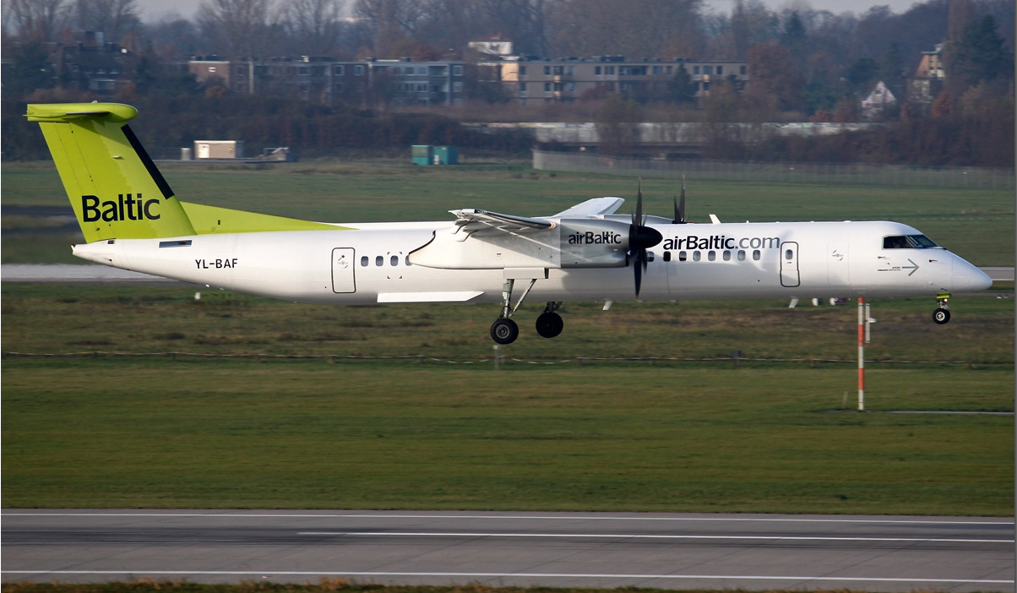

Picture 1

After closing the passenger door, the warning light “FUSELAGE DOORS” on the Caution and Warning Panel came on. Opening and closing passenger doors several times had no effect. The crew called technicians. MEL Item was open and after checking there was established that dispatch permitted according to MEL 52-10-5. The aircraft was released to service, Cabin Pressure Contol System INOP in “AUTO MODE” with time limit 1 (one) flight day. It was the first line training flight for the F/O. Pilot Flying was F/O. During climb “FUSELAGE DOORS” warning light disappeared and until FL 240 flight was normal in manual pressurization mode. After reaching FL 240 the PIC tried to stabilize cabin pressure and it was difficulty to set cabin rate at “0”. Because no more “FUSELAGE DOORS” warning light switched on, PIC decided to set Cabin Pressure Contol System back to Auto Mode. After that cabin started climbing and a rapid depressuarization occurred, then PIC switched Manual Mode again, but it was impossible to control Cabin pressure and shortly the cabin altitude reached 10000 Ft. The crew declared emergency, started emergency descent procedure, returned back and landed in Riga International airport (EVRA).

Notification

The Transport Accident and Incident Investigation Bureau of the Republic of Latvia was notified about the incident on Sunday, December 5, 2010 at 19:40 local time by the duty officer of ARCC Riga, a structural part of LGS responsible for co-ordination of SAR operations within Riga FIR, Riga International Airport.
TAIIB Authorities had evaluated the received information relevant to that case and initiated formal investigation into this serious incident, under the provisions of Annex 13 to the Convention on International Civil Aviation (Chicago 1944) and the Cabinet Regulation No 660, Adopted 25 November 2003. There was forward request to airBaltic of providing documentation and any relevant available information regarding to the aircraft and personal data of flight crew involved in the serious incident.

1. Factual information

  - History of the incident

On Sunday, December 5, 2010 air Baltic aircraft Dash Q-400, registration YL-BAF was on a scheduled passenger service, flight BT-603 from Riga International airport (EVRA), Latvia to Brussels International airport (EBBR), Belgium.
After closing PAX door before flight BT603, door indication “FUSELAGE DOORS” (1) on CAUTION AND WARNING PANEL (CWP) still lit on indicating that door not closed.
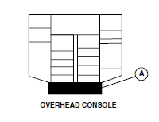+

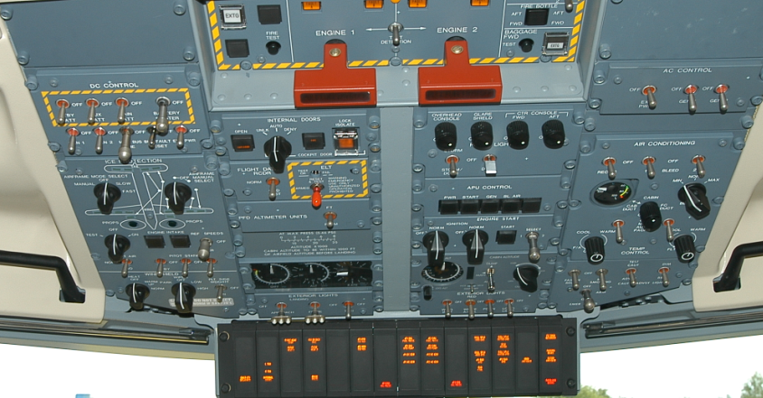

FUSELAGE DOORS WARNING LIGHT

Picture 2, CAUTION AND WARNING PANEL

Aircraft was released to service according to MEL 52-10-5 which says that one door indication may be inoperative provided:
- the affected door is physically verified closed and locked prior to each flight;
- the warning is verified to re-trigger flashing upon any subsequent door opening;
- repairs are made within one flight day.

Climb until FL240 flight was normal with AUTO/MAN/DUMP switch in manual mode on the Cabin Pressure Control Panel and “FUSELAGE DOORS” warning light disappeared. When reached FL240 pilot experienced difficulty to set cabin rate at 0 and as no more “FUSELAGE DOORS” warning persisted, PIC set cabin pressure control in auto mode. Cabin started climbing. After that PIC set pressurization system to manual mode again but it was impossible to control cabin pressure. Shortly cabin altitude reached 10000FT as a result pilots used oxygen masks and initiated emergency descent procedure. Flight diverted back and landed in RIX.
Upon landing, the blow- out panel in the aft cargo compartment was found popped out as well as maintenance suspect ice contamination and snow on the forward passenger door proximity sensors and targets. The blow-out panel was re-installed, ice contamination was removed and passenger door sensors were cleaned, pressuarization check carried out, inductance performed on the passenger door locked and closed sensors and was found within limits. Aircraft was heated in hangar, door seal cleaned, operational test of forward passenger door and pressuarization control system in manual and automatic mode was performed. The testing results were satisfactory.

1.2. Injuries to persons
There were no injuries.
1.3. Damage to aircraft

Not damage occurred.

1.4. Other damage

Objects other than aircraft not damaged.

1.5. Personnel information

PIC: male, 36 years old;

Ratings: All necessary ratings were valid;
Total flight experience - 7845 hrs;
Flying experience as captain (PIC) - 3700 hrs;
Flight experience on aircraft DHC8-Q400-205 hrs;
Flight time last 7 days - 20 hrs;
Flaying hours in incident day – 1hrs 10min.

FO: male, 32 years old;

Ratings: All necessary ratings were valid;
Total flight experience - 2525 hrs;
Flight experience on aircraft DHC8-Q400-3 hrs;
Flight time last 7 days - 00 hrs 00 min;
Flaying hours in incident day - 1hrs 10min.

1.6. AIRCRAFT INFORMATION

Aircraft type - DHC8-Q402; Year of Manufacture 2010; Registration - YL-BAF; Owner of aircraft - „Air Baltic Corporation”; serial No.4293; TOW – 29574 kg; Engines – PW-150A; s/n No 1PCE-FA0654; s/n No 2 PCE-FA0655; Total Time Since New (TTSN) –Flight hours 884; Flight Cycles 684.

1.6.1. Aircraft doors

The forward passenger door of BOMBARDIER DHC-8-400 aircraft is used as the main access to the passenger compartment. Door pressurization loads are carried by ten adjustable pressure stop bolts, five on each side. The stop bolts engage with stop brackets on the door surround structure. The door pressure seal inflates to prevent air leakage. The forward passenger door is the semi-plug type. On opening, the initial movement of the door is upward and inward. The door then rotates outward about the door's hinge.

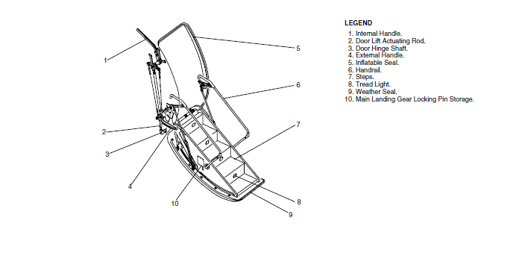Picture 3, The forward passenger door

Internal and external door handles permit manual opening and closing from either the inside or outside of the aircraft. There are two automatically folding handrails, one on each side of the door. Main landing gear lock pins are stored on the forward side of the door structure. An inflatable pressure seal prevents cabin air leakage past the door. The door warning system monitors door status and supplies visual indication and warning in the flight compartment.

The forward passenger door opens and closes manually from either the inside or outside. An internal handle is located in a recess above the forward flight attendant seat. An external handle is located forward of the door, in a recess in the fuselage.

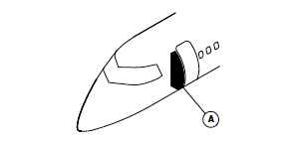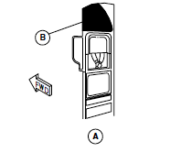
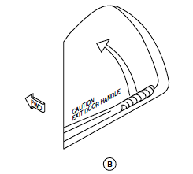

Picture 4, FORWARD PASSENGER DOOR INTERNAL HANDLE LOCATION

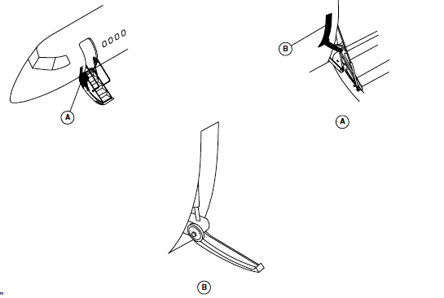

Picture 5, FORWARD PASSENGER DOOR EXTERNAL HANDLE LOCATION

The internal and external handles are interconnected by a cable and chain system. A flush handhold, on the door outer skin, is used to pull the door open from the outside. Handrails on each side of the stairs automatically fold during door closing and unfold during opening. On opening, the initial movement is upward and inward. The door then rotates about a hinge at the bottom of the door.
When the door is in the closed position, door pressurization loads are carried by ten adjustable stop bolts, five on each side of the door. These stop bolts engage with related stop brackets on the door surround structure. Each door stop is inclined downward, so that pressure on the door loads the door downwards towards the closed position. The geometry of the door transporting system is such that, if the door moves away from the fully closed position, cabin pressurization loading applies a downward force on the door, preventing any further movement towards the disengaged position.
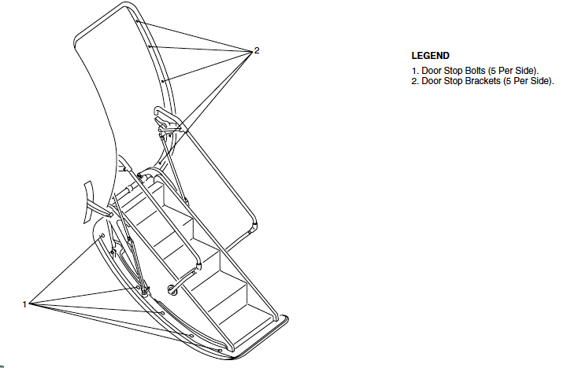

Picture 6, FORWARD PASSENGER DOOR STOP BOLTS

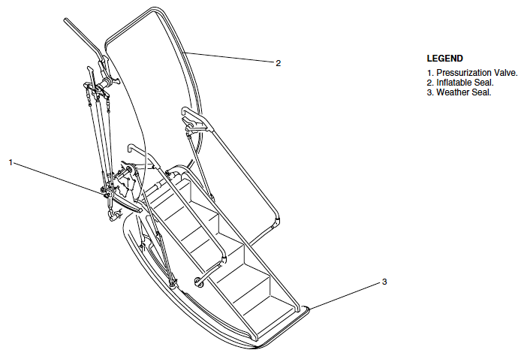
Picture 7, FORWARD PASSENGER DOOR SEAL

The door has an inflatable rubber seal installed on the fuselage structure around the edge of the door opening. Pressurized air to and from the seal is controlled by a pressurization valve operated by a rod assembly in the door lift mechanism. An auxiliary weather seal installed on the upper part of door cut-out seals the door when air pressure is not available.
Opening of the forward passenger door is by operation of either the internal or external handle. The handle force builds up and then decreases when it passes the overcenter position. At the same time, the seal pressurization valve closes and releases seal pressure. The deflated seal vents any residual passenger compartment air pressure. The "locked" proximity switch also disconnects. Further handle travel, through the actuating rod and crank, moves the door upward and inward to clear the ten stop bolts from their stop brackets. The "closed" proximity switch disconnects as the door opens. The door is kept at the lifted position by the counterbalance system. Pushing on the handrails, or pulling on the external handhold then opens the door. The rate of opening is controlled by the gas springs of the counterbalance system. If a gas spring fails, rubber bumpers on each handrail lower strut gives free fall damage protection.
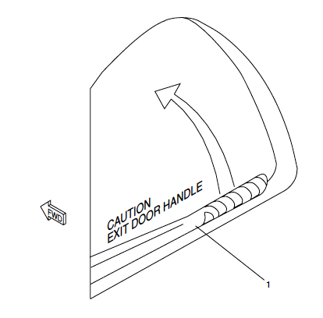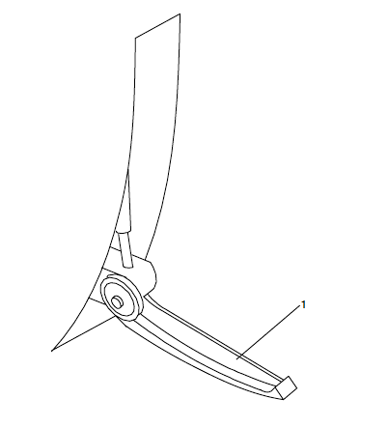

Picture 8, Forward passenger door internal handle Picture 9, Forward passenger door external handle

Closing the door from the inside is done by pulling up on the handrail handles, the motion being assisted by the counter balance system. Operation of the internal handle to the closed position rotates the door hinge shaft, placing the door mechanism including both the actuating rod and the mechanical spring in an overcenter position and locating the stop bolts behind their related stop brackets. Final movement of the door mechanism opens the pressurization valve and inflates the seal, and the door is fully closed and locked. Closing the door from the outside is done by first pushing the handrails inboard to break the overcentre lock, then manually raising and closing the door. Moving the external handle flush with the fuselage locks the door in the same way as the internal handle. During the opening and closing sequences, the gas springs dampen any tendency for high impact at both ends of the door travel.
The aft passenger door is a translating type located at the left side of the fuselage at the rear of the passenger compartment. This door rotates outwards about the two hinges (main and secondary). A stabilizer rod prevents the yawing movement of the door during opening and closing. Door pressurization loads are carried by 12 stops that engage with their related stop brackets on the door surround structure. In unpressurized flight, the door is prevented from sliding upward by the cam rollers on each side of the lift/latch shaft. If one cam roller assembly fails, the remaining cam rollers prevent the door from sliding. The lift/latch shaft is secured in the closed position by both the handle lock mechanism and over-center springs.
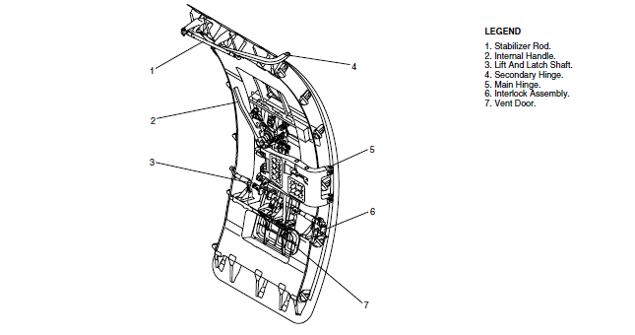

Picture 10, AFT PASSENGER DOOR
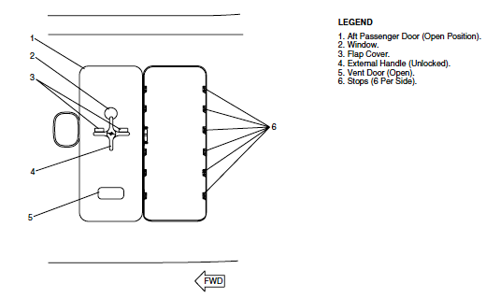
Picture 11, AFT PASSENGER DOOR EXTERNAL VIEW

Both passenger doors can be opened from either the inside or outside using internal or external handles. The forward passenger door is used as the main access to the passenger compartment.

1.6.2. Door Seal Pressurization System

The door seal pressurization system prevents cabin air leakage through the forward passenger and aft baggage doors. Pressurized air is supplied from the airframe deicing system, and from the system reservoir tank when the engines or APU are not operating. The door seal pressurization system has the components that follow:

- Heated check valve
- Reservoir tank
- Control valves
- Door seals
- Drain valve
- Charging valve
- Electro pneumatic shut-off valve
- Plumbing lines.

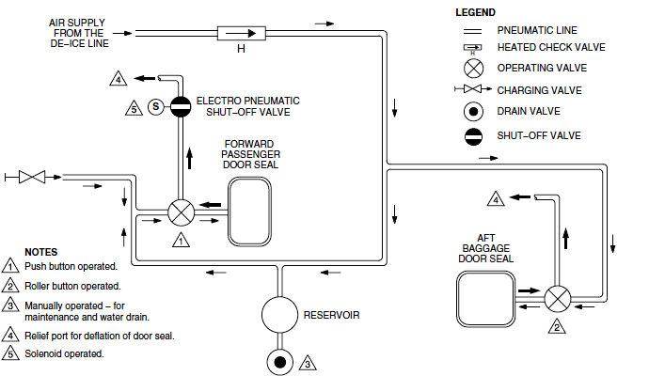

Diagram 1, DOOR PRESSURIZATION SYSTEM

1.6.3. Door Warning System

The door warning system supplies a visual indication, in the flight compartment, when a fuselage door open or unlocked warning condition occurs.
The door warning system sends door sensor outputs to the Proximity Sensor Electronic Unit (PSEU). The PSEU outputs data to the Input Output Processors (IOP 1 and IOP 2). This data is displayed in the flight compartment and is used by the Cabin Pressure Control System (CPCS).
The door warning system monitors the position of the fuselage donors that follow:
- Forward Passenger Door
- Aft Passenger Door
- Type II Emergency Exit Door
- Forward Baggage Door
- Aft Baggage Door
- Aft Service Door
- Type II Emergency Exit Door (52-22-00) (52-23-00)
The door warning system uses two sensors for each of the fuselage doors, and one sensor for the Type II emergency exit.
The door warning system does not monitor the flight compartment emergency hatch.
The fuselage door positions are monitored by 11 proximity sensors, the outputs are received by the Proximity Sensor Electronic Unit (PSEU). The PSEU door position outputs are
sent to the Input Output Processors(IOP 1 & IOP 2) in the Integrated Flight Cabinets (IFC). The data is then sent to the systems that follow:
- The Electronic Flight Information System (EFIS)
- The Caution and Warning Control Panel (CWCP)
- The Cabin Pressure Control System (CPCS)
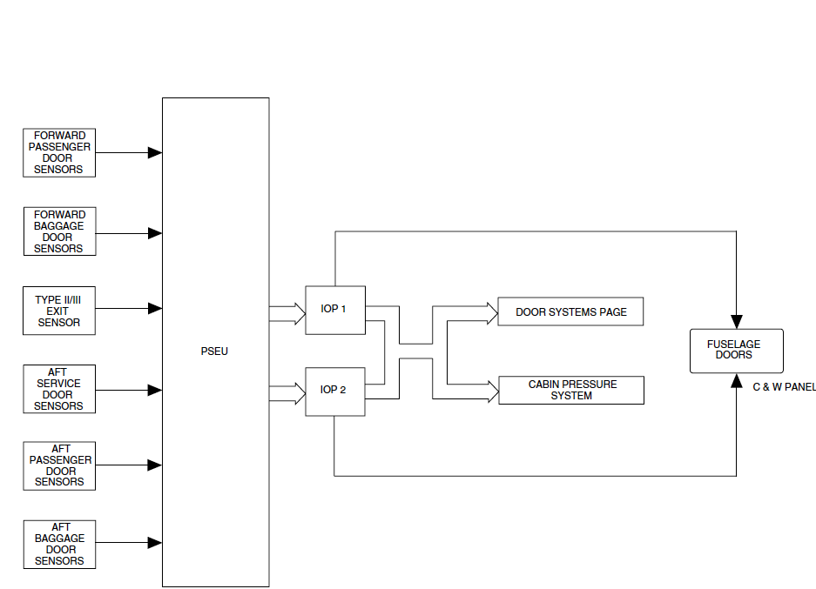

Diagram 2, Door Warning System

When the aircraft is on the ground, weight on wheels, and all the doors are closed and locked, the CPC starts normal ground sequences. When a door is open or unlocked, the CPC starts a door open sequence, which prevents automatic pressurization. Manual pressurization is still available.
The door position signals are stored in the CPCS, when the aircraft leaves the ground. If the memorized signal indicates that the doors are closed and locked, the CPC starts the normal flight operational sequence regardless of the door position signal during flight. A door open signal during flight will not affect the CPCS.
If the memorized signal indicates that the doors are not closed and locked, the CPC will start the door open operational sequence regardless of door position signals during flight. Cabin pressurization will not take place when the CPCS is in the automatic mode.
Note: Discrete inputs to the CPC are continuously monitored by the CPC when the AUTOMATIC mode is engaged.
The PSEU transmits an output signal to the Caution and Warning Control Panel (CWCP) The door position signal is transmitted to the CWCP through two independent paths.The position signals received by the CWCP can be one of the two:
- Electrical ground, door closed and locked;
- Open circuit, door open and/or unlocked;
All door proximity sensor output signals are sent to the PSEU to generate one output signal for each door, in the closed and locked position. This signal is sent to the Input Output Processors (IOP 1 and IOP 2) in the Integrated Flight Cabinets (IFC). The data is processed and displayed on the Doors System page.The output signal is divided to supply each of the IOPs with an independent signal. When the FUSELAGE DOORS warning light is on, the fuselage Doors System page shows any open or unlocked door as a solid red rectangle.
A single failure will not prevent indication of the fuselage door status.
When any door is open and unlocked the indications that follow will be shown:
- The Doors Systems page shows the open door as a red filled rectangle;
- The FUSELAGE DOORS warning light flashes;
- The MASTER WARNING light flashes;
A closed and locked door is shown as green empty rectangle on the Doors System page on the Multi-Function Display (MFD) shows all the fuselage doors and identifies them as:. An open door is shown as a red rectangle with a legend identifying the door in red T1 font.
The doors are identified by the legend that follows:
- “PAX” for the Passenger donors;
- “BAGGAGE” for the Baggage donors;
- “SERVICE” for the Aft Service door;
- “EMERG EXIT” for the Type II emergency exit.
If data from both IOPs is invalid, the Doors System page will show aglobal white “INVALID DATA” message.
When the FUSELAGE DOORS warning light on the Caution and Warning Panel flashes, the MASTER WARNING light also flashes. When the MASTER WARNING light is pushed to acknowledge the warning and the MASTER WARNING light goes off. The FUSELAGE DOORS warning light then stays on continuously as long as the door is open or unlocked. If a subsequent door open/unlocked condition is sensed the FUSELAGE DOORS and MASTER WARNING lights will start flashing again.
When any of the fuselage doors are unlocked, both the FUSELAGE DOORS warning light and the MASTER WARNING light flash. If a fuselage door is not fully closed and locked, the FUSELAGE DOORS warning light and the MASTER WARNING switchlight flash.
Three tones also sound over the flight compartment speakers.
If a fuselage door is not fully closed and locked, the DOORS system page identifies the door and shows it as a red filled rectangle. If the door is fully closed and locked, it is shown only as a green empty rectangle. If the data from the PSEU is invalid, the DOORS system page shows a global white INVALID DATA message.
The PSEU also transmits output signals to the Cabin Pressure Control System (CPCS). If the doors are not closed and locked, the Cabin Pressure Controller (CPC) prevents automatic pressurization of the aircraft.
If the door is not properly closed and locked when the aircraft leaves the ground, the cabin will not pressurize automatically. The aircraft can still be pressurized manually.

1.6.3.1. Proximity sensors

The proximity sensors are hermetically sealed two wire devices, used to sense the distance to targets installed on the fuselage doors. The inductance at the sensor changes with the sensor's proximity to the target. As the target gets closer to the sensor face, the inductance increases and transmits a high signal. High and low signals, for target far or near conditions, are transmitted to the PSEU.
Proximity sensors can fail in one of two modes:
- An open circuit with no output
- A short circuit output
When any proximity sensor fails, a signal is sent to the PSEU, and the FUSELAGE DOORS warning light flashes.
Two proximity sensors are located near each door to indicate when the door is closed and when it is locked. One proximity sensor is installed on the door surround structure and senses when the forward roller guide is in the proper position for latching the door. When this occurs, the door is in the closed position. The other proximity sensor is installed in the door handle housing. It senses whether the handle is retracted (door locked) or extended (door unlocked)

Doors system page Multi-Function Display red filled

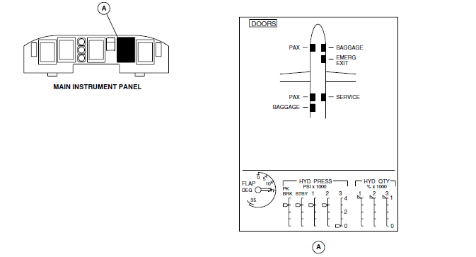
Picture 12, A fuselage door is not fully closed and locked

green empty rectangle
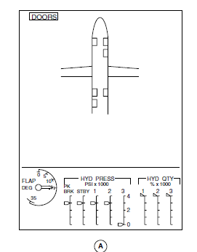

Picture 13, The door is fully closed and locked

1.6.3.2. Forward Passenger Door Monitoring

Two proximity sensors monitor the forward passenger door. One sensor is located at the top aft side of the door, to make sure that the door is closed and fully down. The other sensor, located on the fuselage structure adjacent to the pressurization valve, monitors the lift link position to make sure that the door mechanism is fully overcentre and in safety.

Closed Sensor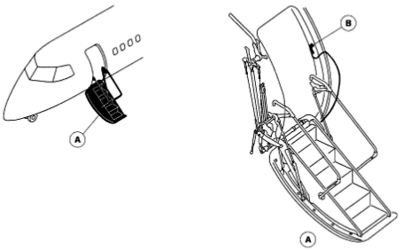

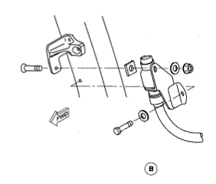
Picture 14, FWD Passenger door sensors location
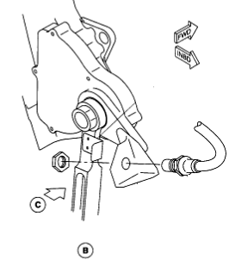
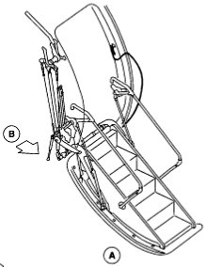
Locked Sensor

Picture 15, FWD Passenger door sensors location

Proximity (closed) sensor location

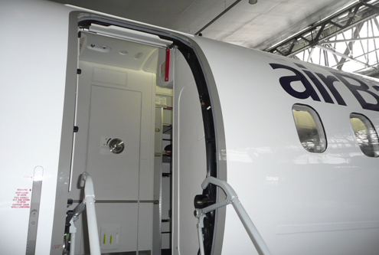

Picture 16, Proximity (closed) sensor location

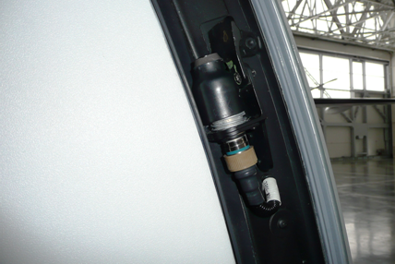

Picture 17, Proximity (closed) sensor

The forward passenger door can be visually inspected to make sure it is closed and locked, by viewing the position of the internal handle. If the door is not locked, the pressurization door seal will not inflate.

1.6.3.3. Aft Passenger Door Monitoring

The position of the aft passenger door is monitored by two proximity sensors. One sensor is located at the aft upper roller guide and make sure that the door is closed. The other sensor was located at the door handle and make sure that the door is locked.

Closed sensor
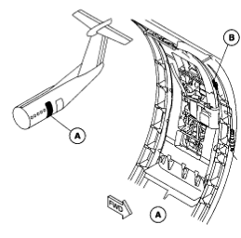
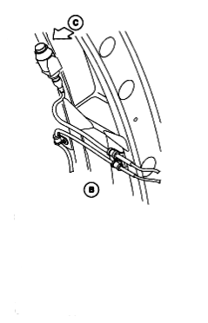

Locked sensor

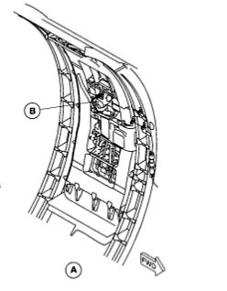
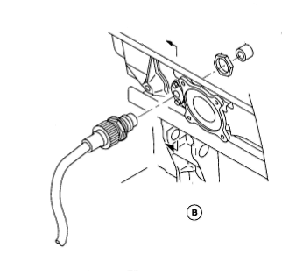
Picture 18, Closed and Locked Sensors of the Aft Passenger Door

The locking mechanism of the aft passenger door can be inspected to make sure that the door is closed and locked. The door can also be checked to be in the locked position, by seeing that the handle mechanism is pushed fully outward and the vent door is closed, or by checking the lift/latch shaft position indicator on the door.
The location of the two proximity sensors for the aft passenger door is similar to that of the aft service and forward baggage doors.
Because of several incidents where the „door locked” sensor on the aft passenger door, forward baggage door and aft service door indicates „locked” at the gate and then during take off or flight indicates „unlocked resulting in aborted take-offs and aircraft turns back, there were performed by manufacturer service bulletins 84-52-63, 84-52-65 and 84-52-68 of relocation locked sensors on the aft passenger doors, forward baggage doors and aft service doors for DHC-8 Aircraft Models 401 and 402 Seial numbers 4001 thru 4346.
It was possible for the door handle to show „locked” when the door is not fully over centre, the handle then subsequently pops out during take-off or flight.

1.6.3.4. Pressuarization control

Limitations of aircraft Air Conditioning and Pressurization system are following:
- normal cabin pressure differential limit 5.46 ± 0.1 psi
- maximum cabin pressure differential limit 5.95 psi
- maximum cabin pressure differential limit during taxiing, take-off and landing 0.5 psi
- maximum cabin altitude (pressurized flight) 8,000 ft

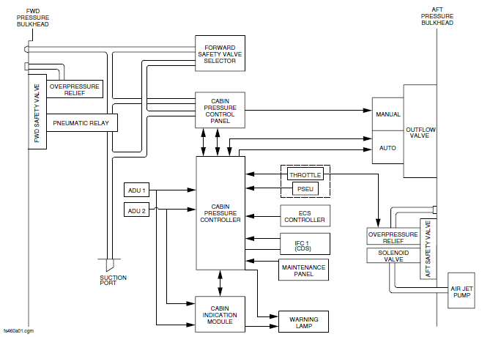

Diagramm 3, Cabin Pressure Control System

The cabin pressure control system keeps a constant cabin pressure during the ground and flight modes. The system controls the cabin altitude and the cabin rate of change. The Cabin Pressure Control Panel controls the system in automatic and manual modes. The Cabin Indication Module shows the data to monitor the system. When cabin altitude is too high, the cabin pressure and the cabin indication module send the warning signal to the aircraft systems.

In the flight compartment the system shows:
- Cabin altitude;
- Cabin altitude rate of change;
- Differential pressure;
- Cabin altitude warning.
The aft outflow valve is for automatic and manual control of the pressurization. The aft outflow valve can also be used to dump the pressurization. The forward safety valve is for emergency operation and for smoke removal from the flight compartment. The aft safety valve and the forward safety valve keep the positive and negative pressure relief constant.
The system functions in the modes that follow :
- Normal/Automatic
- On ground
- Take-off
- Landing
- Emergency/Smoke Removal
- Pressure dump.

Normal/Automatic:

The pressurization control system is electrically operated. The pressurized area of the fuselage is supplied with a constant flow of conditioned air from the engine bleed air systems through the Air Conditioning Unit (ACU). The pressure in the fuselage is controlled by system modulation of the aft outflow valve, to control the amount of air let out of the fuselage. If the external ambient pressure is more than the fuselage pressure, the safety valves will open for negative pressure relief. When electrical power is first supplied to the system, a full electrical test of the system is done. The FAULT alert light, on the Cabin Pressure Control Panel comes on during the power up test mode. If there is a failure in the system, the light will stay on. The system operation is fully automatic with the data programmed into the controller.

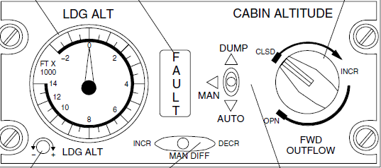

Picture 19, Pressurization System Control Panel

On ground:

When the aircraft is on the ground with the weight on the wheels and the No. 2 engine power lever angle is set less than 60 degrees, electrical power is supplied through the open contacts of the energized landing gear relay. The relay is energized through the Proximity Switch Electronic Unit (PSEU). During the ground mode the aft outflow valve is at the fully open position to prevent aircraft pressurization.

Take-off:

When the No. 2 engine power lever angle is set to greater than 60 degrees the controller sends a signal to the aft outflow valve to open or close, as necessary, to pressurize the aircraft to 400 ft (121.9 m) less than ambient. The aft outflow valve moves from the fully open position and starts to modulate to control the pressure changes that occur after take-off. When the landing gear relay is de-energized after take-off (through the PSEU), the aft outflow valve modulates to keep the set aircraft pressure.

Landing:

The aircraft depressurization is controlled automatically. If the set field altitude is higher than actual field altitude, the aircraft willland unpressurized. If the field altitude is set less than actual field altitude, the aircraft will land pressurized. On landing, cabin altitude will go back to field altitude at the rate programmed into the controller, for one minute before cabin pressure is bled to ambient.

Manual:

The manual mode is used if the automatic pressurization mode does not operate. Pressurization can be controlled through the aft outflow valve, when the AUTO-MAN-DUMP switch is set to MAN. The cabin pressure is set with the toggle switch moved and held to the DECR position, to open the aft outflow valve and increase the cabin altitude. When the toggle switch is moved and held to INCR, the aft outflow valve closes and the cabin altitude decreases.

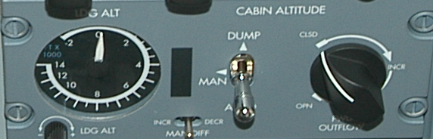

Picture 20, Cabin Pressurizatio System Controll Panel

Emergency/Smoke Removal:

Pressurization can be controlled through the forward safety valve when the AUTO-MAN-DUMP switch is set to MAN. Cabin pressure can be regulated by turning the FWD OUTFLOW knob, as necessary, to adjust the amount of pressure bleed to get the required pressurization selection. When the control knob is turned clockwise the forward safety valve opens and the cabin pressure decreases.Pressurization can also be reduced by operating the forward safety valve selector on the copilot's side console.
If the AUTO/MAN/DUMP switch is set in automatic mode, and the FWD OUTFLOW knob is turned to open the forward safety valve, the cabin pressure will decrease and the aft outflow valve will start to close. When the FWD OUTFLOW knob is set to a higher cabin altitude (lower cabin pressure) than that set in automatic mode it will override the automatic selection. During ground operation with the AUTO/MAN/DUMP switch selected to MAN, the FWD OUTFLOW knob turned fully clockwise (forward safety valve set to open) and all doors and hatches closed, the aircraft will begin to pressurize. The forward safety valve will be slow to start to modulate and cause an increase of cabin pressure.

Pressure dump:

The fast depressurization function may be done in the automatic and the manual modes. The AUTO/MAN/DUMP switch set to DUMP, fully opens the aft outflow valve. In the manual mode, the aft outflow valve opens when the toggle switch is moved and held in the DECR position. On the ground the AUTO/MAN/DUMP switch is set to DUMP, to make sure that all pressure is bled off, before any doors or hatches are opened.

Requirements of AirBaltic OM Part B, Dash 8-400, Temporary Rev 002, Minimum Equipment List, Item 9.52 Doors.

According to Item 52 -10 - 5 FUSELAGE DOORS Warning System, Airstair Door, Forward Baggage Door, Aft Passenger Door and Aft Service Door Proximity Sensors may be inoperative for one door provided:

- the affected door is physically verified closed and locked prior to each flight,
- the warning is verified to re-trigger flashing upon any subsequent door opening, and
- repairs are made within one flight day.
- PLACARD inoperative Door Proximity Sensor in the flight compartment.

OPERATIONS (O)

1. Physically confirm that the affected door is closed and locked prior to each flight:

- For Airstair Door, check that the internal handle is fully down or that the external handle is fully up,
- For Aft Entry Door, Aft Service Door or Forward Baggage Door, check that the external handles are flush. Push the vent panel inward and check that it does not open.

Prior to engine start on the ground, close all doors and press the Master WARNING switchlight.

Check that the FUSELAGE DOORS warning light stops flashing and remains steadily illuminated.

On the ESID control panel, set MFD1 or MFD2 to SYS and select the DOORS page. Check that the five doors not checked in Step 1 are indicating closed and locked.

If the FUSELAGE DOORS warning light still flashes on the ground, repair inoperative door proximity sensor systems.

If the FUSELAGE DOORS warning light flashes in flight, flight must be conducted in accordance with the QRH.

MAINTENANCE (M)

On the ESID control panel, set MFD1 or MFD2 to SYS and select the DOORS page. Determine which proximity sensor or associated wiring is causing the FUSELAGE DOORS warning.

Verify that the affected door is actually in the closed and locked condition:

- For Airstair Door, check that the internal handle is fully down or that the external handle is fully up,
- For Aft Entry Door, Aft Service Door or Forward Baggage Door, check that the external handles are flush. Push the vent panel inward and check that it does not open.

With FUSELAGE DOORS warning light steadily illuminated (by pushing the Master WARNING switchlight if necessary), unlock or open a door not already unlocked or open, and observe that the FUSELAGE DOORS warning light re-triggers flashing.

PLACARD inoperative door proximity sensor in the flight compartment.
Make appropriate entry in the aircraft technical log.

In above mentioned Item of company air Baltic OM Part B there is following warning:

Do NOT select Auto Mode in-flight. The system may immediately revert to a fully open outflow valve, resulting in rapid loss of cabin pressure.

According to OM Part B Q400 Temporary Rev:002 MEL/DDG – Air Conditioning, the Air Transport Association Specification Number 21 Air Conditioning, Item 30 - 5 Cabin Pressure Control system 2) Auto Mode, warning is identical:
Do NOT select Auto Mode in-flight. The system may immediately revert to a fully open outflow valve, resulting in rapid loss of cabin pressure.

Revision Status of Minimum Equipment List (MEL):

MEL iss based on the Dash 8 Series 400 JAA MMEL Supplement (Revision 4 dated 24 January 2008) to the Department of Transport, Canada MMEL, PSM 1-84-16A (Revision 4 dated 24 January 2008).

MEL of Air BALTIC OM Part B Q400 Temporary Rev:002 Chapter 9.21 Air conditioning, pages 17-18 and Chapter 9.52, Doors, pages 5-6 were approoved by CAA of Latvia 01.12.2010 and Effective from December 09, 2010.

The reason of introducting Rev 002 was add warning about using „AUTO MODE”. Rev002 approved by Chief Pilot of airBaltic and CAA of Latvia and were effective since December 09, 2010.

In Master MEL of Bombardier Inc. DHC-8 Series 400 Rev 4 Jan 24/2008 Item 52-10-5 is following

NOTE:
An inoperative door warning system sensor will render AUTO Mode of the Cabin Pressure Control System inoperative.

Rectification Periods

Repairs are to be accomplished at the earliest opportunity and not later than the repair time intervals established by the following letter designators given in the "INTERVAL" column of the MEL.
For category A - Either before next flight or within the time interval specified in the REMARKS AND EXCEPTIONS of the MEL.
Whenever the time interval is specified in calendar days, it shall start at 00:01 on the calendar day following the day of discovery. A flight day means A 24-hour period (from midnight to midnight) during which at least one flight is initiated for the affected aeroplane.

Abnormal and Emergency Procedures

Cabin Pressurization Problems
Unpressurized aircraft must be maintained at 10 000' feet or at the lowest safe altitude, if higher. Prolonged flight at altitudes above 14 000' shall be avoided and every opportunity is used including re-routing to descent below above mentioned altitudes as soon as practicable.
Flight crew shall use OXYGEN when Cabin Altitude is above 10 000'. Rapid cabin pressure change is easy to recognise but time available to fix the problem is limited, prompt pilots actions are required.
If Early recognition the algorithm for the course of actions should be as follow:

- Stop Climb to level/altitude above 10 000' feet (ALT HOLD);
- Ensure Supply (BLEED AIR, PACKS),
- Ensure Control (OUTFLOW VALVE is controlled in MAN mode).
Complete Appropriate Non-normal checklist -"CABIN PRESS" (Warning Light) or „LOSS OF CABIN ALTITUDE, CABIN RATE and CABIN DIFF INDICATORS(All Indicators at Zero)” Ensure proper pressurisation system settings and operation before any further climb is requested or excepted.
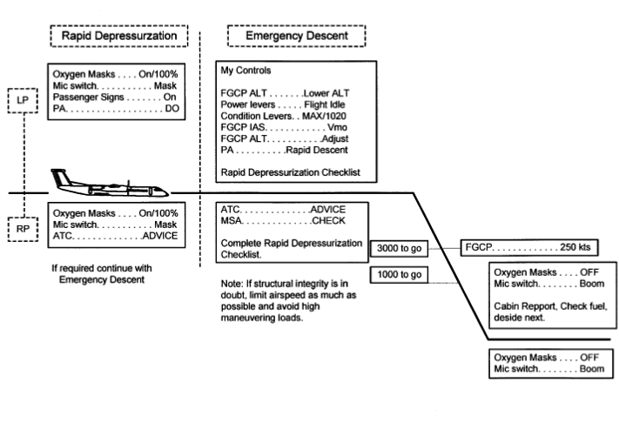Diagramm 4, Abnormal and Emergency Procedures

1.7. Meteorological information

1.8. Aids to Navigation

NIL

1.9. Communications

NIL

1.10. Aerodrome information

NIL

1.11. Flight recorders

NIL

1.12. Wreckage and impact information

Not damage

1.13. Medical and pathological information

NIL

1.14. Fire

There was no fire

1.15. Survival aspects

NIL

1.16. Tests and research

NIL

1.17. Organizational and management information

1.18. Additional information

NIL

1.19. Useful or effective investigation techniques

2. Analysis

2.1. General

On December 05, 2010 after closed PAX door before flight BT603, door indication came on indicating that door not closed. Aircraft was released to service according to MEL 52-10-5 which says that one door indication may be inoperative provided the affected door is physically verified closed and locked prior to each flight and warning is verified to re-trigger flashing upon any subsequent door opening. Cabin pressurization system can be used only in manual mode, respectively flight BT603 departed with PAX door indication „inop” and cabin pressurization system in manual mode.
During flight cabin crew both felt some pain in the ears which was not normal (more painful than usual).One of them decided to tell about this to pilots. She pressed the button to call pilots for enter the cockpit, when opened the doors and at the same time felt huge pressure on ears and saw Captain putting on oxygen mask. She understood what is happening and closed doors immediately and shouted pax to sit down and fasten seat belts. Cabin crew still felt some pain in the ears but it was becoming less. They opened equipment storage and pulled out oxygen masks, it was not able to understand if aircraft descent or not. At that moment one pax seated about row 12 - 14 became white and collapsed. Pax were shouting to get my attention. Cabin crew member showed then to "hit" her on chest. After some 20 seconds she came back. Then cabin crew received a call from PIC. He asked how they were. They answered that ok, only one pax has some problems. He told what is happening (decompression) and that now we are on safe altitude and heading back to RIX. He told that will give info to pax as well.

2.2.Sequence of Events before and after incident

Within framework of analyse aircraft Q-400 maintenance, examinating different technical logs and occurrence notifications investigation stated that there were other cases with cabin pressurization system and aircraft doors indication problems before and after incident that occurred on December 05, 2010.
- Entry was made in techlog SEQ No 00012 on August 14, 2010, YL-BAF, flight No326 – automatic pressurization failure, „FAULT” light came on during flight
Actions taken – cabin pressure controller was replaced according to AMM 21-31-06, rev 33 pressurizarion control functional test performed, according to AMM 21-31-00, rev 32, result satisfactory.

- Entry was made in techlog SEQ No 00195 on October 11, 2010, YL-BAF, flight No601 –cabin unable to pressurize. During flight cabin rate of climb =aircraft rate of climb.
Actions taken – ATA 21 Air Conditioning, AFT out –flow valve was replaced according to AMM 21-31-16, rev 33, functional test out-flow valve performed according to AMM 21-31-16, rev 33, result satisfactory.
- 28.11.2010 EYVI-LFPG, YL-BAH- After take-off, after 15 min of flight, we trigged with "fuselage doors" warning light. Multi-functional-display showed open AFT LEFT ENTRY DOOR. Cabin attendants visually confirmed security and closed operating handle position at the effected door, no air whistle sound. In cockpit pressurisation system showed that pressurisation is normal. According to QRH, we have land at the nearest suitable airport. We decided to return back to EYVI. After landing, technicians found a partly closed door. Visually, from the inside and outside the door looks closed, but when push with hand the vent panel inward from outside - it opens, external handles rise, which indicates that the door is not fully closed.
Technicians informed, that the AFT LEFT PAX door, RIGHT AFT SERVICE door and the FORWARD BAGGAGE door have similar feature and design - fully closed door position can be checked with hand from the outside only.
- 29.11.2010 EVRA-EBBR, YL-BAF- above 4000’ in climb after takeoff checklist executed the crew noticed cabin rate was matching aircraft rate of climb. The crew observed for confirmation that this was not temporary, at FL100 “Cabin press” warning came. They leveled off at FL105 and requested FL090, performed “Cabin press” checklist, made another climb to FL100 to confirm, problem not solved, then turned back to RIX.

- 01.12.2010 EVRA-EBBR, YL-BAF- Climbing through FL105 the fuselage door warning light illuminated along with warning chime. The crew informed ATC we would stop climb at FL120. The QRH was consulted and executed, ATC was informed and request for a return for landing was made to ATC RIX. After parking visual inspection showed the door to be closed, but the handle was extended and not stowed. Technicians examined the handle and released the aircraft as fit to fly. OCC informed; refueled, requested new documents and then departed for BRU. No tech log entry was made.
- Entry was made in techlog SEQ No 00199 on December 01, 2010, YL-BAF – cabin unable pressure during flight
Actions taken – ATA 21 Air Conditioning, cabin pressure controller was replaced according to AMM 21-31-06, rev 33, operational test performed, according to AMM 21-31-06/405, rev 33, result satisfactory.

- Before flight, entry about current serious incident was made in techno SEQ No 00207 and 00209 on December 05, 06 2010, YL-BAF, PAX door indication is on when door is closed.
Actions taken – No confirmed fault (may be as ice and snow accumulation on proximiry sensor and target). PSEU checked for airstar door fault, no faults recorded, inductance PADRCL & PADRLK in limits. i.a.w. AMM52-71-01, rev 33. Operational test of FWD passenger door proximity sensors performed i.a.w. AMM31-62-00, rev 33 satisfactory. Aircraft released to service i.a.w. MEL 52-10-5, Def. Category A, time limit one flight day.

- After landing entry about current serious incident was made in techlog SEQ No 00208 and 00213 on December 05, 06, 2010, YL-BAF, cabin depressurization at FL240 (rapid). Pressurization system was in manual MODE according MEL 52-10-5.
Actions taken – ATA 21 Air Conditioning, found AFT cargo compartment AFT blow-out panel is out, AFT cargo door seal was inspected visually, leak check performed i.a.w. AMM 12-10-52 satisfactory. Suspect ice contamination on door seal, blow out panel installed back i.a.w. AMM 25-52-00, aircraft heated in hangar, door seal cleaned, functional test of pressuarization control system in manual and automatic mode performed i.a.w. AMM 21-31-00-720. rev33, results satisfactory.

- Entry was made in techlog SEQ No 00227 on December 10, 2010, YL-BAF – during climb “Fuselage Doors” light came on (AFT baggage doors light indicated in MFD)
Actions taken – ATA 52 Doors- functional test of AFT Baggage doors was performed 1.a.w. AMM52-31-00-720-801 rev 34, result satisfactoryDue to winterization recommendation aircraft manually pressurized acc. AMM 21-oo-00-863-801 rev 34, result satisfactory.

- Entry was made in techlog SEQ No 00230, 00231, 00232, 00233, 00234 on December 11, 12, 13 2010, YL-BAF – AFT Baggage doors door was difficult to close, during AFT Baggage door closing mechanism inspection was found FWD lower cam follower needle bearing broken; During check the door balance mechanism i.a.w. AMM 52-31-21-400-801 was found FWD and AFT rod assembly (29) length 134,2mm.
Actions taken – ATA 52 Doors- AFT Baggage door cam follower needle bearing (FWD lower) was replaced i.a.w. AMM 52-31-06, rev 33, AFT baggage door rigging was performed i.e. AMM52-31-00, rev33, satisfactory, test of the AFT baggage door was performed i.e. AMM52-31-00, rev33, satisfactory, AFT baggage door closing mechanism and balance mechanism inspection, AFT baggage door liner and upper surround removed i.e. AMM 25-52-16, rev33, AFT baggage door liners and upper surround was installed i.e. AMM 25-52-16, rev33.

2.3. Sequence of Events before departure Fligt BT603

On December 05, before flight BT-603 from EVRA, when indication “FUSELAGE DOORS” (passenger) was warning when door was closed, it was checked that the door actually was in the closed and locked position- the internal handle was fully down and the external handle was fully up. Pressuarization system was in “MANUAL MODE”. Because “FUSELAGE DOORS” warning light signal stays continuously, that means the inductance did not increase, which generates signal by the sensors proximity to the target. There was an open circuit with no output at least from one door’s sensor and consequently warning system did not send door’s sensor output signal to the PSEU and the “FUSELAGE DOORS” warning light flashes.
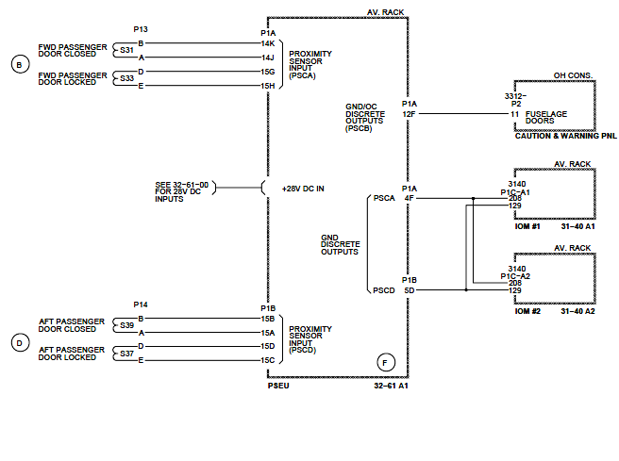
Diagramm 5, Passenger Door System Electrical Schematic

The PSEU sends data to the input Output Processors I and II and then signals were send to the systems:
- The Electronic Flight Information System (EFIS)
- The Caution and Warning Control Panel (CWCP)
- The Cabin Pressure Control System (CPCS)
The door position signal is transmitted to the CWCP through two independent paths. The position signals received by the CWCP can be one of the two:
- Electrical ground, door closed and locked;
- Open circuit, door open and/or unlocked;
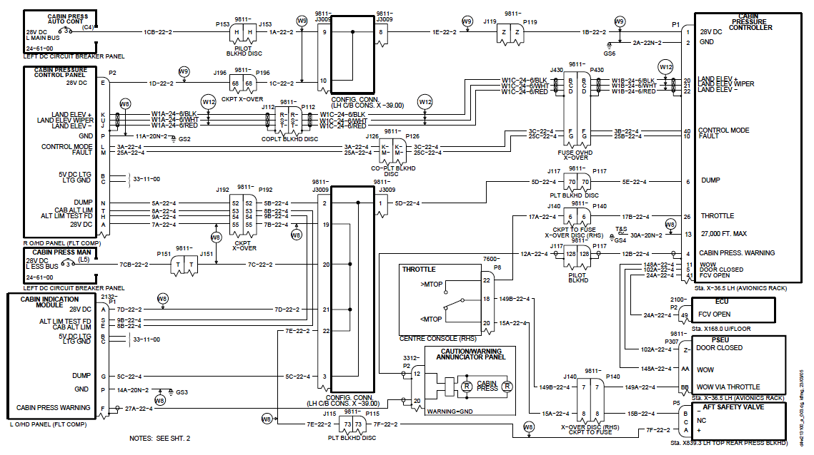

Diagramm 6, Cabin Pressurizatio Controll System
On ground: When the aircraft is on the ground with the weight on the wheels and the No. 2 engine power lever angle is set less than 60 degrees, electrical power is supplied through the open contacts of the energized landing gear relay. The relay is energized through the Proximity Switch Electronic Unit (PSEU). During the ground mode the aft outflow valve is at the fully open position to prevent aircraft pressurization.
Take-off: When the No. 2 engine power lever angle is set to greater than 60 degrees the controller sends a signal to the aft outflow valve to open or close, as necessary, to pressurize the aircraft to 400 ft (121.9 m) less than ambient. The aft outflow valve moves from the fully open position and starts to modulate to control the pressure changes that occur after take-off. When the landing gear relay is de-energized after take-off (through the PSEU), the aft outflow valve
modulates to keep the set aircraft pressure.
The CABIN PRESS warning light on the Caution and Warning panel comes on when the cabin altitude reaches 10,000 ft (3048 m), except when take-off or landing altitude is above 8000 ft (2438.4 m). For take-off or landing altitudes above 8000 ft (2438.4 m) the warning light will come on in the conditions that follow:
- The aircraft take-off altitude + 1000 ft (304.8 m)
- Landing altitude + 1000 ft (304.8 m)

2.4. Sequence of Events during flight BT603

After take-off during climb “fuselage doors” warning light disappeared. Pressurization system was in “MANUAL MODE” and aircraft continued climbing until FL240. As no more “FUSELAGE DOOR” warning persisted, PIC set Pressurization system control in „AUTO MODE”. Because the door position signals when aircraft leaves the ground before take-off were stored in memory of CPCS as that the doors are not closed and locked the CPC started the door open operational sequence regardless of door position signals. As a result cabin started climbing. After that PIC set pressurization system to “MANUAL MODE” again, but it was impossible to control cabin pressure because CPC continued door open operational sequnce and consequenly cabin pressurization could not take place when CPCS was in the AUTO MODE”. Shortly cabin altitude reached 10000 ft as a result pilots initiated emergency descent procedure and flight diverted back and landed in RIX. On ground during inspection was found that aft cargo compartment aft blow out panel is out. This indicates Delta P between the cargo and cabin department.

2.5. Sequence of Events and occurrence analyze after emergency landing flight BT603

Investigation stated that mostly fault indications related to aircraft doors warning occurred in winter time, during cold weather conditions, when is possibility of contamination of ice and snow on door proximity sensors. Similar siituation occurred before flight BT 603. With high probability there is possibility to develop ice lyer on proximity sensors during aircraft standing in cold weather conditions, because location place of forward passenger door sensors is open for atmospheric precipitation. As a result of such thin ice layer is insufficient inductance level, when target gets close to the sensor face and signal is not sent to the PSEU, and the „FUSELAGE DOORS” warning comes on, despite that the interval limits between sensor and target are satisfactory and sensor is not fault, PSEU doesn't send signal to cabin pressurization system to pressurize system in auto mode and pressurization is available only in manual mode.
Information about door configuration status memorized in CPCS and changes in door indication during flight cannot affect pressurization system, memory still keep signal as door open indication. The same situation is if during flight door indication fault comes on, CPCS still keep in memory configuration as on ground and no pressurization system is affected – auto mode still operative.

2.6. Underlying Human Factors problems associated with incident

For revealing causation of this incident it was put into practice the taxonomy of the Human Factors Analysis and Classification System that describes the human factors that contribute to an incident. It is based on a sequential or chain-of-events theory of accident causation. The human contribution don’t build on the person approach, that focuses on the errors and violations of individuals but is based on the system approach, that traces the causal factors back into the system as a whole. The investigation view is not that Human Error is a cause of incident but that Human Error is a symptom of trouble deeper inside a system. The classification system has four levels, each of which influences the next level. These four levels are called:
- organizational influences;
- unsafe supervision;
- preconditions for unsafe acts;
- unsafe acts of operators;
Human factors played the major role in the cause of this incident and this further reinforces the requirements to examine the role of human factors in the Air Traffic Control.

2.7. Unsafe acts of operators

The unsafe acts can be loosely classified into two categories: errors and violations.

I. Errors

During investigation here were fixed following errors that ultimately led to the serious incident:

1. Skill- Based error

- the crew during flight BT603 failed to take into account notes and warnings ITEM 52-105 of airBaltic OM Part.

2. Decision errors

- Poor decision of PIC to set Pressuarization system control in „AUTO MODE” during flight.

II. Violations

- Investigation didn’t reveal any violations such as willful disregard for the rules and regulations that govern safe flight.

2.8. Preconditions for unsafe acts

Two major unsafe subdivisions of unsafe conditions are developed:
- substandard conditions of operators;
- substandard practices of operators.

I. Substandard conditions of operators

Investigation didn’t reveal any substandard conditions of operators such as adverse mental states, physiological states as well as physical/mental limitation.

II. Substandard practices of operators

Generally speaking, the substandard practices of operators can be summed up in two categories:
- resource mismanagement;
- personal readiness.
Within the context of this incident this includes coordination both within and between aircraft crew technical service facilities. There were not revealed any poor coordination among aircrew and technical services.
Personal readiness failures occur when individuals fail to prepare physically or mentally for duty. Within the context of this incident there not revealed personal readiness failures when operators fail to prepare physically or mentally for duty.

2.9. Unsafe supervision

Exist four categories of unsafe supervision:
- inadequate supervision;
- planned inappropriate operations;
- failure to correct a known problem;
- supervisory violations.

Within the context of this incident there was not reveled any inappropriate supervision of operations.

2.10. Organizational factors influencing incidents

Fallible decisions of upper-level management directly affect supervisory practices, as well as the conditions and actions of operators. The most elusive of latent failures revolve around following issues of organizational influences:

- Resource management;
- Organisational climate;
- Operational process.

Within the context of this incident there were not find lack of human resources, budget resources, deficient planning, as well as were not find any adversarial, or conflicting, or when they are supplanted by unofficial rules and values and confusion abounds that could to have influence on creation of this serious incident.

3. Conclusions

3.1. Findings

- The flight crew was licensed and qualified for the flight in accordance with applicable regulations;
- The flight crew held valid medical certificates and was medically fit to operate the flight;

- The flight crew was adequately rested and their flight and duty times were in compliance with EU OPS Sub Part Q Flight and Duty Time Limitations and Rest Requirements;
- After open-closing PAX door before flight BT603, door indication “FUSELAGE DOORS” (1) on CAUTION AND WARNING PANEL (CWP) still lit on, indicating that door not closed;
- Aircraft was released to service according to MEL 52-10-5 with with PAX door indication and cabin pressure control system INOP in auto mode;
- Cabin pressure control system was selected in “MANUAL MODE”;

- In Master MEL of Bombardier Inc. DHC-8 Series 400 Rev 4 Jan 24/2008 Item 52-10-5 is following NOTE: An inoperative door warning system sensor will render AUTO Mode of the Cabin Pressure Control System inoperative;

- In air Baltic OM Part B, rev 001 was introduced following warning: Do NOT select Auto Mode in-flight. The system may immediately revert to a fully open outflow valve, resulting in rapid loss of cabin pressure;

- air Baltic OM Part B, rev 001 was approved by CAA 01.12.2010, effective from 09.12.2010;

- It was the first line training flight for the F/O;

- Pilot flying during flight BT603 was FO;

- During climb “fuselage doors” warning light disappeared to extinguished;

- Climb until FL240 flight was normal with manual pressurization;

- After reaching FL240 PIC set cabin pressure control in AUTO MODE;

- When cabin started climbing PIC set cabin pressure control in MANUAL MODE again;

- After setting pressurization system to manual mode again it was impossible to control cabin pressure;

- Shortly cabin altitude reached 10000 FT;

- Pilots used oxygen masks and initiated emergency descent procedure;

- Setting cabin during flight by pilot in AUTO MODE was incorrect and to contrary with NOTE in Master MEL of Bombardier Inc. DHC-8 Series 400 Rev 4 Jan 24/2008 Item 52-10-5 – „An inoperative door warning system sensor will render AUTO Mode of the Cabin Pressure Control System inoperative”;

- PIC did not know Cabin Pressure Control System algorithms, that system inoperativeness could render inoperative door warning system sensor;

- Master MEL of Bombardier Inc. DHC-8 Series 400 Rev 4 Jan 24/2008 Item 52-10-5 did not consist strict rules or warning about setting Cabin Pressure Control System in Auto Mode during flight and consequences if set on in Auto Mode;

- rev 002 in airBaltic OM Part B, about inadmissible to set Cabin Pressure Control System in Auto Mode and consequences of such operation, was made after incident;

- The post-occurrence inspection revelead that the aft cargo compartment aft blow out panel was dislodged, which equalised differential pressure between the rear pressure bulkhead and the aft cargo compartment;
- on Q400 aircraft there were several cases with nuisance fault indication related to door warning;

- mostly fault indications related to aircraft doors warning occurred in winter time, during cold weather conditions;

- location place of passenger door sensors is open for atmospheric precipitation during standing when door is open;

- it is possible contamination by ice and snow on door proximity sensors.

3.2. Causes

Causes of the serious incident - cabin depressurization of aircraft DHC-8-402, registered YL-BAX, flight BT603, were the following:

3.2.1. Proximate Cause

The source or origin of an event that caused this incident was the fact that the Pilot in Comand due to lack of experience of aircraft type (200 flying hours on aircraft DHC8-Q400) as well as competency of Cabin Pressure Control System algorithms set on system in MANUAL MODE.

3.2.2. Root Cause

The factors that resulted this incident are location of aircraft passenger doors proximity sensors, which is open for unfavourable environment - atmospheric precipitation, ice and snow contamination of sensors during weather conditions with low temperatures.

3.2.3. Contributing causes

Documentation of Bombardier Inc. DHC-8 Series 400 Rev 4 Jan 24/2008 did not consist strict rules or warning about consequences if Cabin Pressure Control System is set on in Auto Mode during flight.

Preliminary rev 002 in airBaltic OM Part B, about inadmissible to set Cabin Pressure Control System in Auto Mode and consequences of such operation, was made when serous incident occurred, despite first problems with DHC-8 Series 400 presurization system occurred and repeated since August 2010.

Insufficient experience of flight and technical services with maintaining new type aircraft.

3.2.4. Primary cause

The event after which incident became inevitable.

Not possibility to control cabin pressure (increasing of cabin altitude) regardless that system was switched back from auto to manual mode, because the algorithms of Cabin Pressure Control System are such that it would take some time till system stabilizes.

4. Safety Recommendations

As a result of the investigation of this accident, the Transport Accident and Incident Investigation Bureau Republic of Latvia recommends the following:

Recommendation - 9-2011

Require airplane manufacturer Bombardier Inc. to relocate passenger door sensors to places inaccessible for atmospheric precipitation to avoid ice and snow contamination on sensors and erroneous door fault indication.

Recommendation - 10-2011

Bombardier Inc. provide revising the Dash 8-400 Master Minimum Equipment List PSM 1-84-16A (DOT) Revision 4, Item MEL 52-10-5 by a Placard to the Cabin Pressure Control System panel stating:
„WARNING: DO NOT select Auto Mode in-flight. The system may immediately revert to a fully open outflow valve, resulting in rapid loss of cabin pressure.”

Recommendation - 11-2011

Company Air Baltic take action to emphasize flight crew training and awareness in relation to Cabin Pressure Control system algorithms and possible sequences of selecting system in auto mode during flight.

Recommendation - 12-2011

Company Air Baltic take action for enhancing the design of the Preflight checklist to better distinguish between items referring to the air conditioning and the pressurization systems of the aircraft and to include an explicit line item instructing flight crews of setting the pressurization mode
selector to AUTO.

Recommendation - 13-2011

CAA of Latvia should verify continued compliance with the applicable requirements of operations and implementation of appropriate recommendations taking into account the specific nature of the company and the complexity of its activities. The oversight programm should based on the assessment of associated risks.

Riga February 15, 2012

Director of Transport Accident and Incident
Investigation Bureau Ivars Alfreds Gaveika

Investigator in charge – Head of Aircraft Accident and Incident
Investigation Department Visvaldis Trubs

